COMP9900 23T3

Information Technology Project

Project Proposal

P23 Web Platform for Connecting Professionals with Projects

**Group Number:** 9900M13AOKBUDDY

**Submission Date:** 30/09/2023

|  |  |  |  |
| --- | --- | --- | --- |
| **Full Name** | **Email** | **zID** | **Role** |
| Vincent Julio Jap | z5218165@ad.unsw.edu.au | z5218165 | Backend |
| Eric Li | z5191532@ad.unsw.edu.au | z5191532 | Backend |
| Nicholas Jovanka | z5471931@ad.unsw.edu.au | z5471931 | Backend |
| Satrio Raffani Raharjo | z5467103@ad.unsw.edu.au | z5467103 | Frontend |
| Sheina Edeline Tengara | z5190299@ad.unsw.edu.au | z5190299 | Scrum Master, Frontend |

Table of Contents

Background 3

Introduction 3

Relevant Systems 3

Upwork 3

Freelancer 3

Problem Statement 4

User Stories and Sprints 4

User Types Summary 4

Epic Stories 4

User Stories 4

All/Common Users 4

Company Users 7

Professional Users 10

Admin Users 12

Backlog 13

Sprint Planning 13

First Sprint - Jira 14

Storyboards 14

Company Storyboard 14

Login and Register 14

View Profile and Logout 15

Create New Project, View Projects, and Edit Existing New Project 15

Manage Professionals in Projects 16

View Professional User Profile 17

Professional Storyboard 18

Login and Register 18

View/Edit profile, View Other Professional Profile, and Logout 19

Search Projects, View Project Profile, View Company Profile 20

Project Application, Check Project Detail, and Rating the Project Upon Completion 21

Admin Storyboard 22

Login and Home Page 22

System Architecture 23

User Types (External Actors) 24

Professional Users 24

Company Users 24

Platform Admin 24

System Architecture Layers 24

Interface Layer 24

Business Layer 24

Database Layer 25

References 26

# Background

Introduction  
In today's fast transforming global economy, the paradigm of work is shifting away from the conventional model of full-time employment and toward alternative work arrangements that are more flexible, and project based. (Lau, 2021). This transition is primarily motivated by the reciprocal advantages it offers to both businesses and professionals. Many highly skilled individuals are actively seeking opportunities to engage in meaningful and rewarding project work, thereby enhancing their competencies while also generating income. In parallel, businesses are constantly searching for professionals with specialized skill sets capable of executing specific projects with utmost efficiency. Despite the apparent compatibility of needs, a significant challenge persists in the form of a communication gap between these entities (Bragin, 2018). The absence of a robust, user-friendly, and dedicated platform hinders the smooth interaction between companies offering projects and professionals seeking project work. This inefficiency leads to lost opportunities, delayed project executions, and underutilization of skilled resources.

Relevant Systems

Current systems endeavour to mitigate this communication barrier with various levels of effectiveness. Websites like Upwork and Freelancer serve as platforms where individuals can bid on company posted projects. However, these platforms have their shortcomings which are identified as follow:

### Upwork

* **Competitive Bidding Systems:** Upwork operates on a bidding model, which often results in a race to the bottom where professionals often underbid each other in order to participate in the projects they want to join. This adversely affects the earning potential for professionals and undermines the quality of work on the side of companies.
* **High Fees:** The platform charges a significant portion of the freelancer’s earnings as service fees, which diminishes the financial appeal for both the professionals and the companies, making the platform less welcoming for both parties.

### Freelancer

* **Lack of Professional Vetting:** Freelancer’s platform does not have a rigorous vetting process or system to validate the qualifications and expertise of individuals profiles. This lax vetting may potentially lead to companies hiring less qualified individuals. Thus, affecting the quality and period of projects being delivered. Moreover, it may also create trust issues between companies and project workers.
* **Generic Project Listings:** Project listings on Freelancer often lack the requisite details, making it a herculean task for professionals to understand the project requirements fully. Similarly, companies find it challenging to attract the right talent due to inadequate project descriptions.

Problem Statement

This project aims to develop a web-based platform for connecting professionals with real-world projects to address the above identified problems in the existing systems. The proposed platform will focus on creating a streamlined, user-friendly interface where companies can post projects with clear, comprehensive listings, and professionals can showcase their expertise through vetted profiles. By addressing the drawbacks of existing systems, this platform will foster a conductive environment for fruitful collaborations between companies and professionals. Therefore, bridging the existing communication gap in the project-based work domain.

# User Stories and Sprints

User Types Summary

* **Visitor:** A new user who has never visited the website before and is currently not registered to the website.
* **User:** A current user with different roles who is currently registered to the website. (Admin/Company/Professional)
* **Company User:** Individuals belonging to a company that post projects from their company onto the website to find skilled individuals to join and work on the project.
* **Professional User**: A skilled individual that is looking for projects to join into on the website.
* **Admin User:** Website Administrator that manages and oversees the website.

Epic Stories

1. Login and registration
2. View/edit profile
3. Feed categorisation and filtering
4. Company project management
5. View/edit individual project
6. Project application
7. Notification
8. Project completion
9. Admin system control

User Stories

Our application has 9 main functionalities/objectives. Below are user stories mapped to each functionality with the acceptance criteria also outlined under each story. All user stories have been defined in Jira including the priority based on 1 Low, 3 Medium, and 5 High story points.

### All/Common Users

| ID | 1 |
| --- | --- |
| Feature | Login and registration |
| User Story | As a **visitor**, I want to be able to view an introduction of the website, so that I can decide if I want to register and explore further. |
| Acceptance Criteria | Given that I have on the landing page, when I scroll around the page, then I will be able to view descriptions and features provided in the platform. |
| Priority | High (1 Low, 3 Medium, 5 High) |

|  |  |
| --- | --- |
| ID | 2 |
| Feature | Login and registration |
| User Story | As a **visitor**, I want to be able to choose either a company or professional account, so that I can access the right services from the website. |
| Acceptance Criteria | Given that I have not registered before, when I am in the process of signing up, then I will have to choose either a company user or a professional user. |
| Priority | High (1 Low, 3 Medium, 5 High) |

|  |  |
| --- | --- |
| ID | 3 |
| Feature | Login and registration |
| User Story | As a **visitor**, I want to register an account by filling in the required information depending on the user type, so that I can access the website/app and its services |
| Acceptance Criteria | Given that I am a company user type, when I click the register button, then I will have to fill in a form consisting of username, password, name, address, ABN, industry type, company website, email, phone number, and a brief description.  Given that I am a professional user type, when I click the register button, then I will have to fill in a form consisting of username, password, name, address, email, Date of Birth, phone number, LinkedIn link. |
| Priority | High (1 Low, 3 Medium, 5 High) |

|  |  |
| --- | --- |
| ID | 4 |
| Feature | Login and registration |
| User Story | As a **user**, I want to login with my credentials, so that I can interact and use the website's services for my own needs. |
| Acceptance Criteria | Given that I have registered an account, when I visit the application again, then I will have to login to access the application’s features and my details. |
| Priority | High (1 Low, 3 Medium, 5 High) |

|  |  |
| --- | --- |
| ID | 5 |
| Feature | Login and registration |
| User Story | As a **user**, I want to be able to logout, so that I can protect my account from unauthorized access. |
| Acceptance Criteria | Given that I have logged in my account, when I click the Logout button, then I will no longer be able to access my details and the application’s features. |
| Priority | High (1 Low, 3 Medium, 5 High) |

|  |  |
| --- | --- |
| ID | 6 |
| Feature | Login and registration |
| User Story | As a **user** who forgets their password, I want to receive a temporary password via email, so that I can login into my account again. |
| Acceptance Criteria | Given that I am trying to login to my account, when I click the forget password button, then I will receive a temporary password. |
| Priority | Medium (1 Low, 3 Medium, 5 High) |

|  |  |
| --- | --- |
| ID | 7 |
| Feature | View/edit profile |
| User Story | As a **user**, I want to be able to view my profile, so that I can ensure all my information is up-to-date and correct. |
| Acceptance Criteria | Given that I have logged in to my account, when I click on my profile, then I will be directed to another page with my personal details. |
| Priority | High (1 Low, 3 Medium, 5 High) |

|  |  |
| --- | --- |
| ID | 8 |
| Feature | View/edit profile |
| User Story | As a **user**, I want to be able to edit my profile, so that I can update my information. |
| Acceptance Criteria | Given that I am on my profile, when I click the edit button, then I will be able to change my personal details. |
| Priority | High (1 Low, 3 Medium, 5 High) |

|  |  |
| --- | --- |
| ID | 9 |
| Feature | View/edit profile |
| User Story | As a **user**, I want to be able to change my password, so that I can protect my account. |
| Acceptance Criteria | Given that I am on my profile, when I click the change password button, then I will be able to change my password. |
| Priority | Low (1 Low, 3 Medium, 5 High) |

|  |  |
| --- | --- |
| ID | 10 |
| Feature | Login and registration |
| User Story | As a **visitor**, I want to be able to choose relevant industry tags, so that I can get better recommendations. |
| Acceptance Criteria | Given that I am creating an account, when I have chosen either a company or a professional user, then I will be able to choose tags to specify the industry I am interested in. |
| Priority | High (1 Low, 3 Medium, 5 High) |

### Company Users

|  |  |
| --- | --- |
| ID | 11 |
| Feature | Company project management |
| User Story | As a **company user**, I want to be able to create a new project post, so that professionals can apply for my project. |
| Acceptance Criteria | Given that I have logged in as the company, when I have a new project, then I will create a new project post to publicize it.  Project posts may include project title, tags, description, start and end date, number of professionals, expected working hours, skills, experiences, online/offline, price/budget, required criteria/information from professionals when they’re applying. |
| Priority | High (1 Low, 3 Medium, 5 High) |

|  |  |
| --- | --- |
| ID | 12 |
| Feature | Company project management |
| User Story | As a **company user**, I want to be able to view my project lists and its details, so that I can ensure all the information is up-to-date. |
| Acceptance Criteria | Given that I have logged in, when I click the My Projects button, then I will be directed to another page with all my projects. |
| Priority | High (1 Low, 3 Medium, 5 High) |

|  |  |
| --- | --- |
| ID | 13 |
| Feature | Company project management |
| User Story | As a **company user**, I want to be able to filter my project lists, so that I can easily find which projects are new, ongoing or completed. |
| Acceptance Criteria | Given that I have posted projects, when I am at My Projects page, then I can filter my projects using the search box. |
| Priority | High (1 Low, 3 Medium, 5 High) |

|  |  |
| --- | --- |
| ID | 14 |
| Feature | Feed categorisation and filtering |
| User Story | As a **company user**, I want to be able to view a list of professionals, so that I can invite them to apply for the company’s project. |
| Acceptance Criteria | Given that I am the home page, when I click on the Professional header button, then I will be directed to another page with all the professionals registered in the platform. |
| Priority | High (1 Low, 3 Medium, 5 High) |

|  |  |
| --- | --- |
| ID | 15 |
| Feature | View/edit profile |
| User Story | As a **company user**, I want to be able to view a professional’s profile, so that I can inspect if they are suitable for the company. |
| Acceptance Criteria | Given that there is a professional card on the page, when I click on it, then I will be directed to another page containing the professional’s profile. |
| Priority | High (1 Low, 3 Medium, 5 High) |

|  |  |
| --- | --- |
| ID | 16 |
| Feature | Project application |
| User Story | As a **company user**, I want to be able to send an invite to a professional, so that they can work on my project. |
| Acceptance Criteria | Given that I am viewing a professional’s profile page, when I think that they would be a good candidate for the project, then I can click a button to send them an invite to join. |
| Priority | High (1 Low, 3 Medium, 5 High) |

|  |  |
| --- | --- |
| ID | 17 |
| Feature | Company project management |
| User Story | As a **company user**, I want to be able to edit my project lists and its details, so that I can ensure all the information is correct. |
| Acceptance Criteria | Given that I am at a page with all the details of my project, when I click on the edit button, then I can start editing the project’s information. |
| Priority | High (1 Low, 3 Medium, 5 High) |

|  |  |
| --- | --- |
| ID | 18 |
| Feature | View/edit individual project |
| User Story | As a **company user**, I want to be able to view professionals who have requested to work on my project, so that I can approve or reject them. |
| Acceptance Criteria | Given that I am at a page with all the details of my project, when I scroll down the page, then I can view all professionals that have applied to work on the project. |
| Priority | High (1 Low, 3 Medium, 5 High) |

|  |  |
| --- | --- |
| ID | 19 |
| Feature | View/edit individual project |
| User Story | As a **company user**, I want to be able to view the professionals who are approved to join a project, so that I can ensure that the list is correct. |
| Acceptance Criteria | Given that I am at a page with all the details of my project, when the project has started, then I can view all professionals that have been approved for the project. |
| Priority | High (1 Low, 3 Medium, 5 High) |

|  |  |
| --- | --- |
| ID | 20 |
| Feature | Project completion |
| User Story | As a **company user**, I want to be able to mark a project as completed, so that I can rate and recognise the professionals involved. |
| Acceptance Criteria | Given that I am at a page with all the details of my project, when the project has completed, then I can mark it as completed and begin rating the professionals involved. |
| Priority | High (1 Low, 3 Medium, 5 High) |

|  |  |
| --- | --- |
| ID | 21 |
| Feature | Project completion |
| User Story | As a **company user**, I want to be able to rate the professional users who contributed to the project, so that they can receive recognition for completing the project. |
| Acceptance Criteria | Given that I am at a page with all the details of my project, when the project has been marked completed, then I can rate each professional involved using a 5 star rating and give some remarks on their contribution. |
| Priority | Medium (1 Low, 3 Medium, 5 High) |

|  |  |
| --- | --- |
| ID | 22 |
| Feature | Feed categorisation and filtering |
| User Story | As a **company user**, I want to view and filter the available project lists, so that I can find the projects aligned to my enquiry. |
| Acceptance Criteria | Given that I have logged in. when I am at the home page, then I can view and filter the public projects available. |
| Priority | High (1 Low, 3 Medium, 5 High) |

### Professional Users

|  |  |
| --- | --- |
| ID | 23 |
| Feature | Feed categorisation and filtering |
| User Story | As a **professional user**, I want to be able to view all available projects, so that I can start finding projects to apply for. |
| Acceptance Criteria | Given that I have logged in. when I am at the home page, then I can view all the public projects available. |
| Priority | High (1 Low, 3 Medium, 5 High) |

|  |  |
| --- | --- |
| ID | 24 |
| Feature | Feed categorisation and filtering |
| User Story | As a **professional user**, I want to be able to search through available projects, so that I can find projects that align with my interests. |
| Acceptance Criteria | Given that I have logged in. when I am at the home page, then I can filter the projects available based on tags. |
| Priority | High (1 Low, 3 Medium, 5 High) |

|  |  |
| --- | --- |
| ID | 25 |
| Feature | View/edit individual project |
| User Story | As a **professional user**, I want to be able to select a certain project, so that I can view the full details of the project. |
| Acceptance Criteria | Given that I am browsing for a project, when I click on a project card, then I will be directed to another page with the project’s details. |
| Priority | High (1 Low, 3 Medium, 5 High) |

|  |  |
| --- | --- |
| ID | 26 |
| Feature | Project application |
| User Story | As a **professional user**, I want to be able to request to join a project, so that I can work on it. |
| Acceptance Criteria | Given that I am at a project page, when I click the apply button, then I can submit my application to do the project. |
| Priority | High (1 Low, 3 Medium, 5 High) |

|  |  |
| --- | --- |
| ID | 27 |
| Feature | Project application |
| User Story | As a **professional user**, I want to receive a confirmation of my project request, so that I know the application was sent successfully. |
| Acceptance Criteria | Given that I have finished filling the project application, when I click the submit button, then I will receive a confirmation saying my application has been sent. |
| Priority | Low (1 Low, 3 Medium, 5 High) |

|  |  |
| --- | --- |
| ID | 28 |
| Feature | Notification |
| User Story | As a **professional user**, I want to receive a notification if my request has been accepted or rejected, so that I know when to start to work on the project. |
| Acceptance Criteria | Given that I have applied to work on a project, when the company is going through the project’s applications, then I will receive an email based notification system to see the outcome for my application. |
| Priority | Medium (1 Low, 3 Medium, 5 High) |

|  |  |
| --- | --- |
| ID | 29 |
| Feature | Project completion |
| User Story | As a **professional user**, I want to rate my experience working on the project once it is completed, so that I can provide feedback and insight on the company for other users. |
| Acceptance Criteria | Given that the company user has marked the project as completed, when I am at the project page, then I can rate my experience by giving a remark and the 5 star rating. |
| Priority | Medium (1 Low, 3 Medium, 5 High) |

|  |  |
| --- | --- |
| ID | 30 |
| Feature | Project completion |
| User Story | As a **professional user**, I want to be able to receive a certificate of recognition from the company, so that I can build my account and prove that I have completed the project. |
| Acceptance Criteria | Given that I have contributed to the project, when the company has marked the project as completed, then I will receive a certificate of recognition from the company. |
| Priority | High (1 Low, 3 Medium, 5 High) |

|  |  |
| --- | --- |
| ID | 31 |
| Feature | View/edit profile |
| User Story | As a **professional user**, I want to be able to view my list of completed projects and reviews, so that I can keep track of my previous works. |
| Acceptance Criteria | Given that I have worked on projects, when I am at my profile page, then I can view my list of completed projects and reviews at the lower part of the page. |
| Priority | High (1 Low, 3 Medium, 5 High) |

|  |  |
| --- | --- |
| ID | 32 |
| Feature | View/edit profile |
| User Story | As a **professional user**, I want to be able to have the option to upload supplementary documents such as PDF of my resume, experiences, tags, and a biography, so that I can substantiate my qualifications, skills, and expertise. |
| Acceptance Criteria | Given that I am at my profile page, when I click the edit button, then I can upload and include more information. |
| Priority | High (1 Low, 3 Medium, 5 High) |

|  |  |
| --- | --- |
| ID | 33 |
| Feature | View/edit profile |
| User Story | As a **professional user**, I want to be able to view a company’s profile,  so that I can learn more about the company and view their available projects. |
| Acceptance Criteria | Given that I have logged in, when I click on a certain company, then I will be directed to its profile page. |
| Priority | High (1 Low, 3 Medium, 5 High) |

### Admin Users

|  |  |
| --- | --- |
| ID | 34 |
| Feature | Admin system control |
| User Story | As an **admin**, I want to have full privilege of the system, so that I can manage and oversee the platform. |
| Acceptance Criteria | Given that I have the admin role, when I enter in my correct account credentials, then I can log in to the platform. |
| Priority | High (1 Low, 3 Medium, 5 High) |

|  |  |
| --- | --- |
| ID | 35 |
| Feature | Admin system control |
| User Story | As an **admin**, I want to be able to see overall statistics, so that I can observe the platform’s performance. |
| Acceptance Criteria | Given that I have logged in, when I am at the home page, then I can observe the overall statistics of the application. Statistics include number of ongoing projects per year, number of completed projects per year, number of professional users, number of company users, number of total projects per year. |
| Priority | High (1 Low, 3 Medium, 5 High) |

Backlog  
All of the user stories were added into the backlog section in Jira before moving them into each sprint.

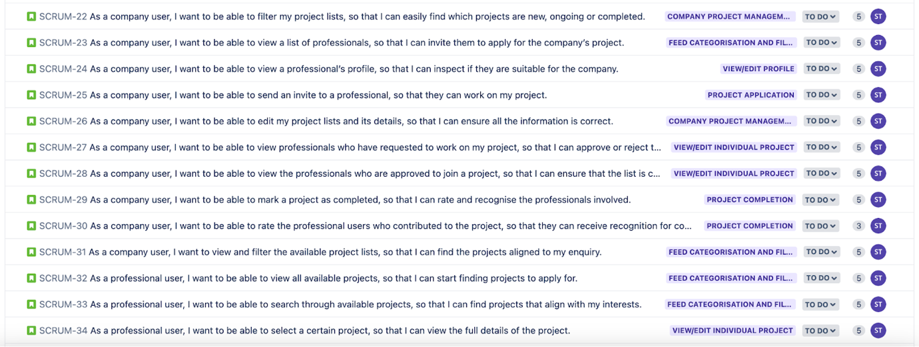

Sprint Planning

|  |  |  |
| --- | --- | --- |
| **SCRUM Sprints** | **Duration** | **Date** |
| Sprint 1 | Week 3 lab - Week 5 lab | 25 Sep - 9 Oct |
| Sprint 2 | Week 5 lab - Week 8 lab | 9 Oct - 23 Oct |
| Sprint 3 | Week 8 lab - Week 10 lab | 23 Oct - 6 Nov |

First Sprint - Jira

# Storyboards

Figma and Google services were used to create storyboards of the application features and functionalities, based on the epic stories. [Figma link](https://www.figma.com/file/5mQ4XJ2h7MDNEK1s3ph48D/Design-Interface?type=design&node-id=84%3A59&mode=design&t=taWrFR6QYbrsYNrP-1).

Company Storyboard

### Login and Register

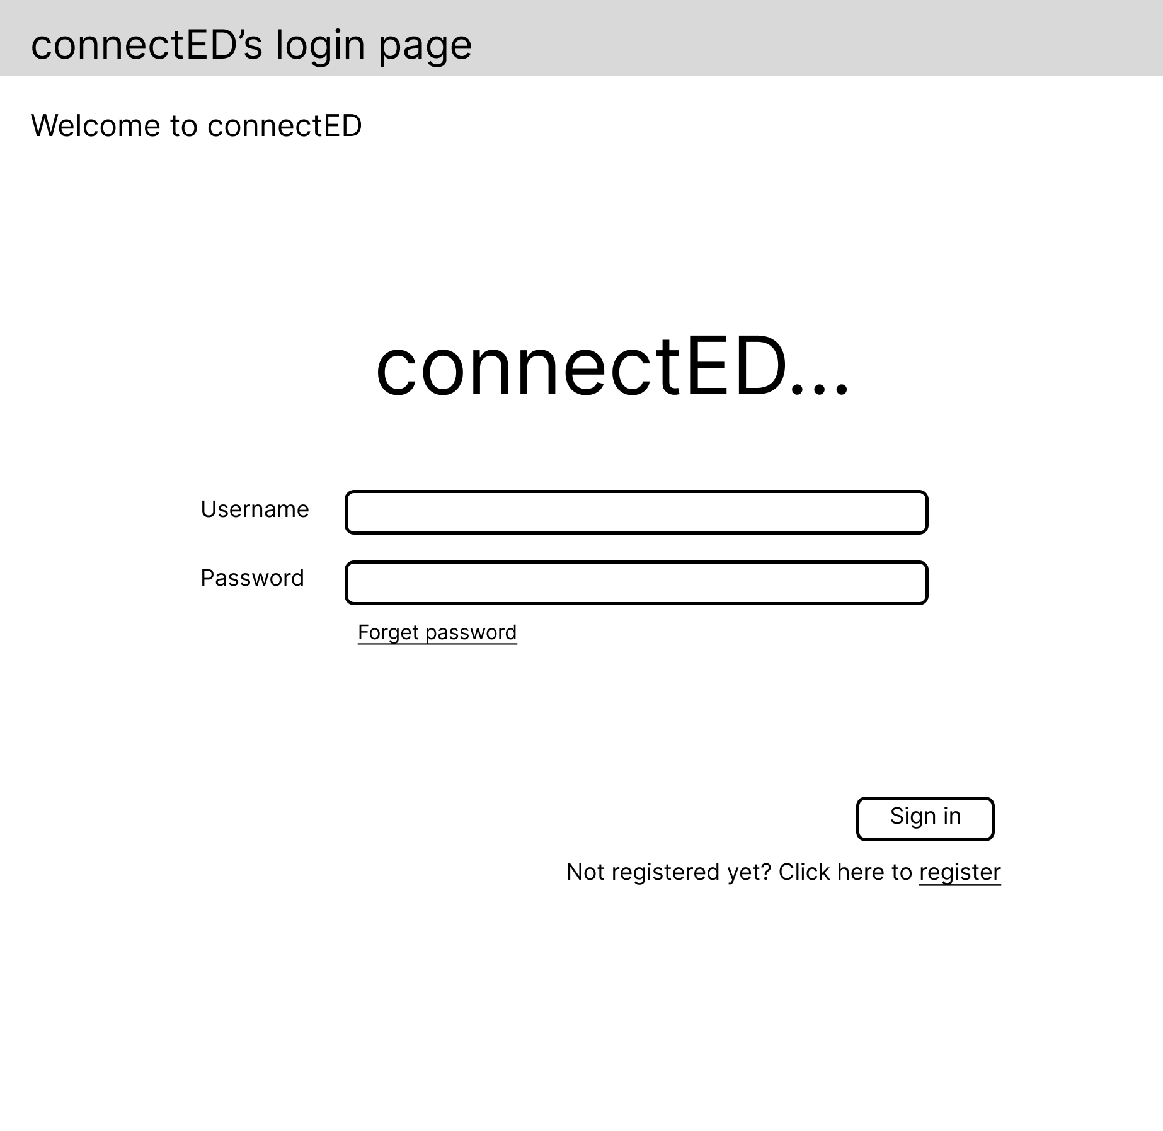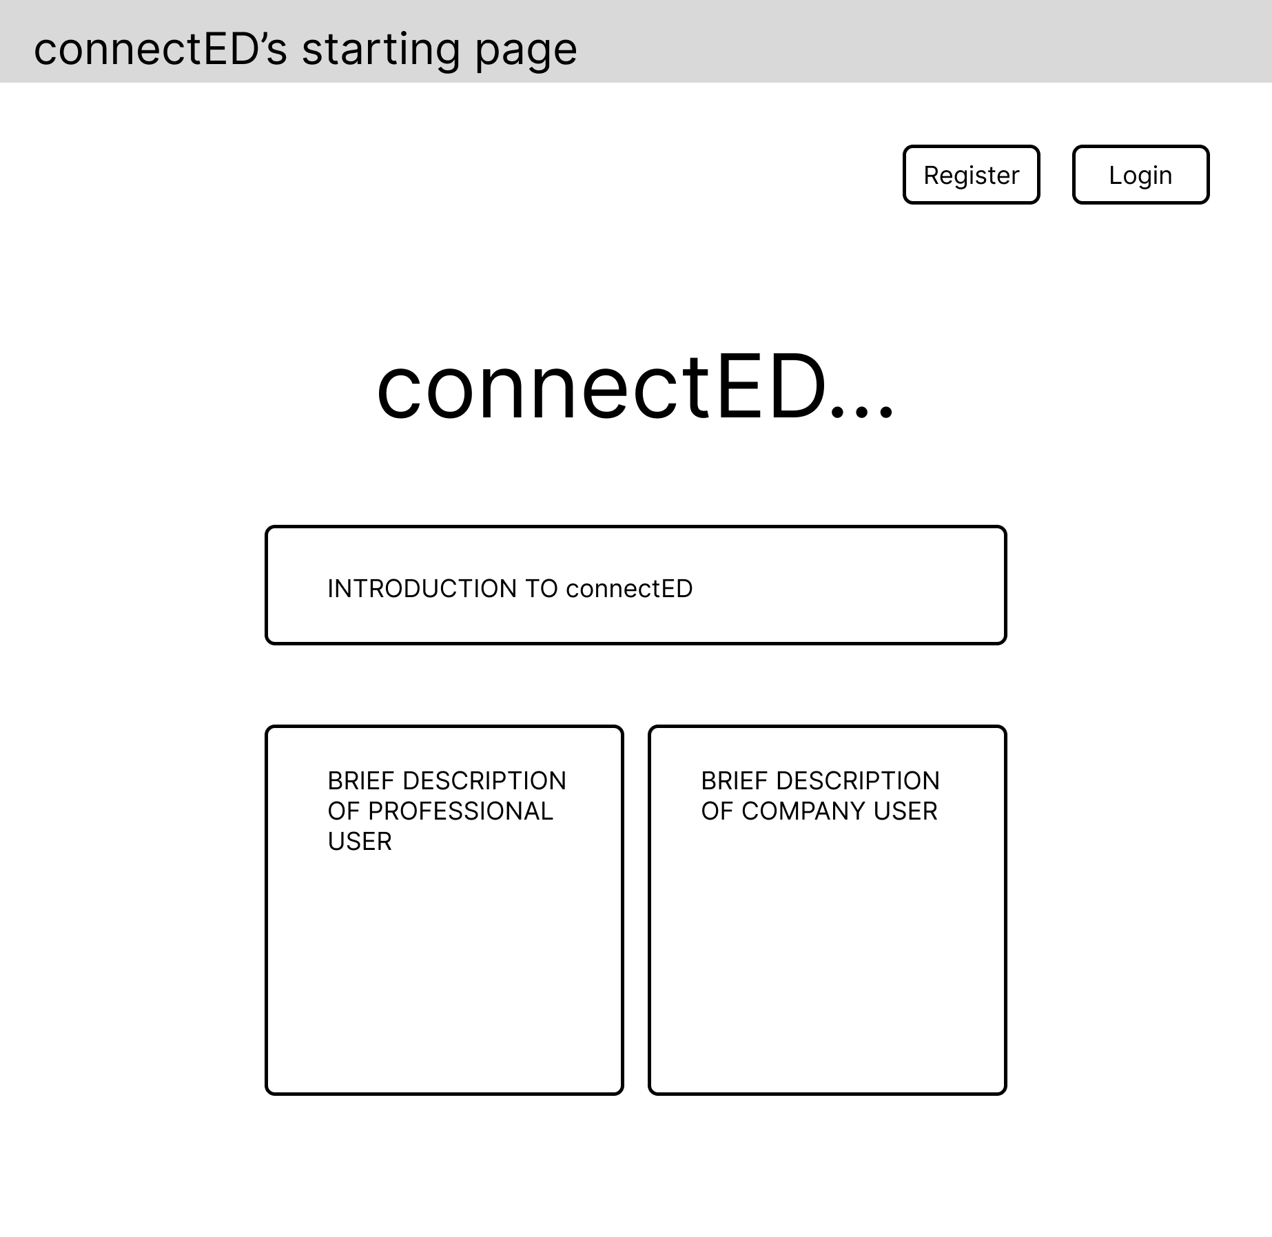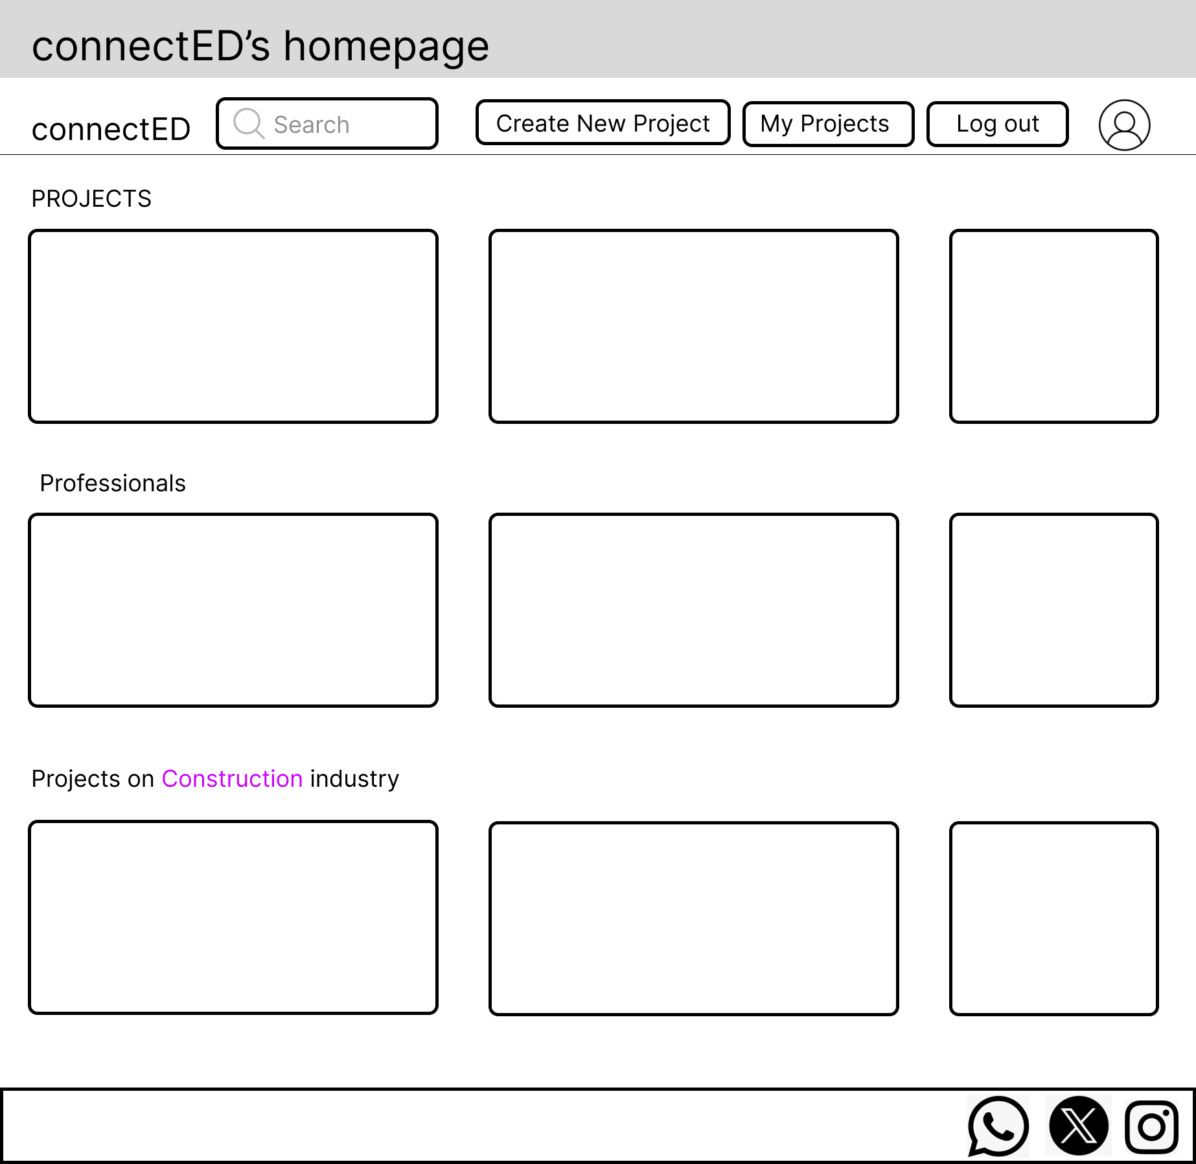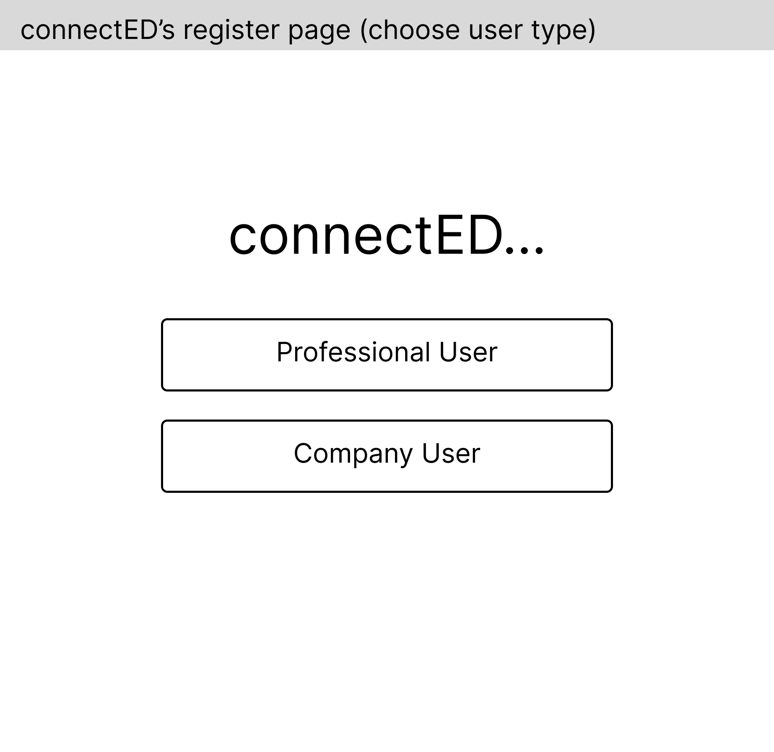

Visitor clicks login

Visitor clicks Register Account

Visitor clicks Company user

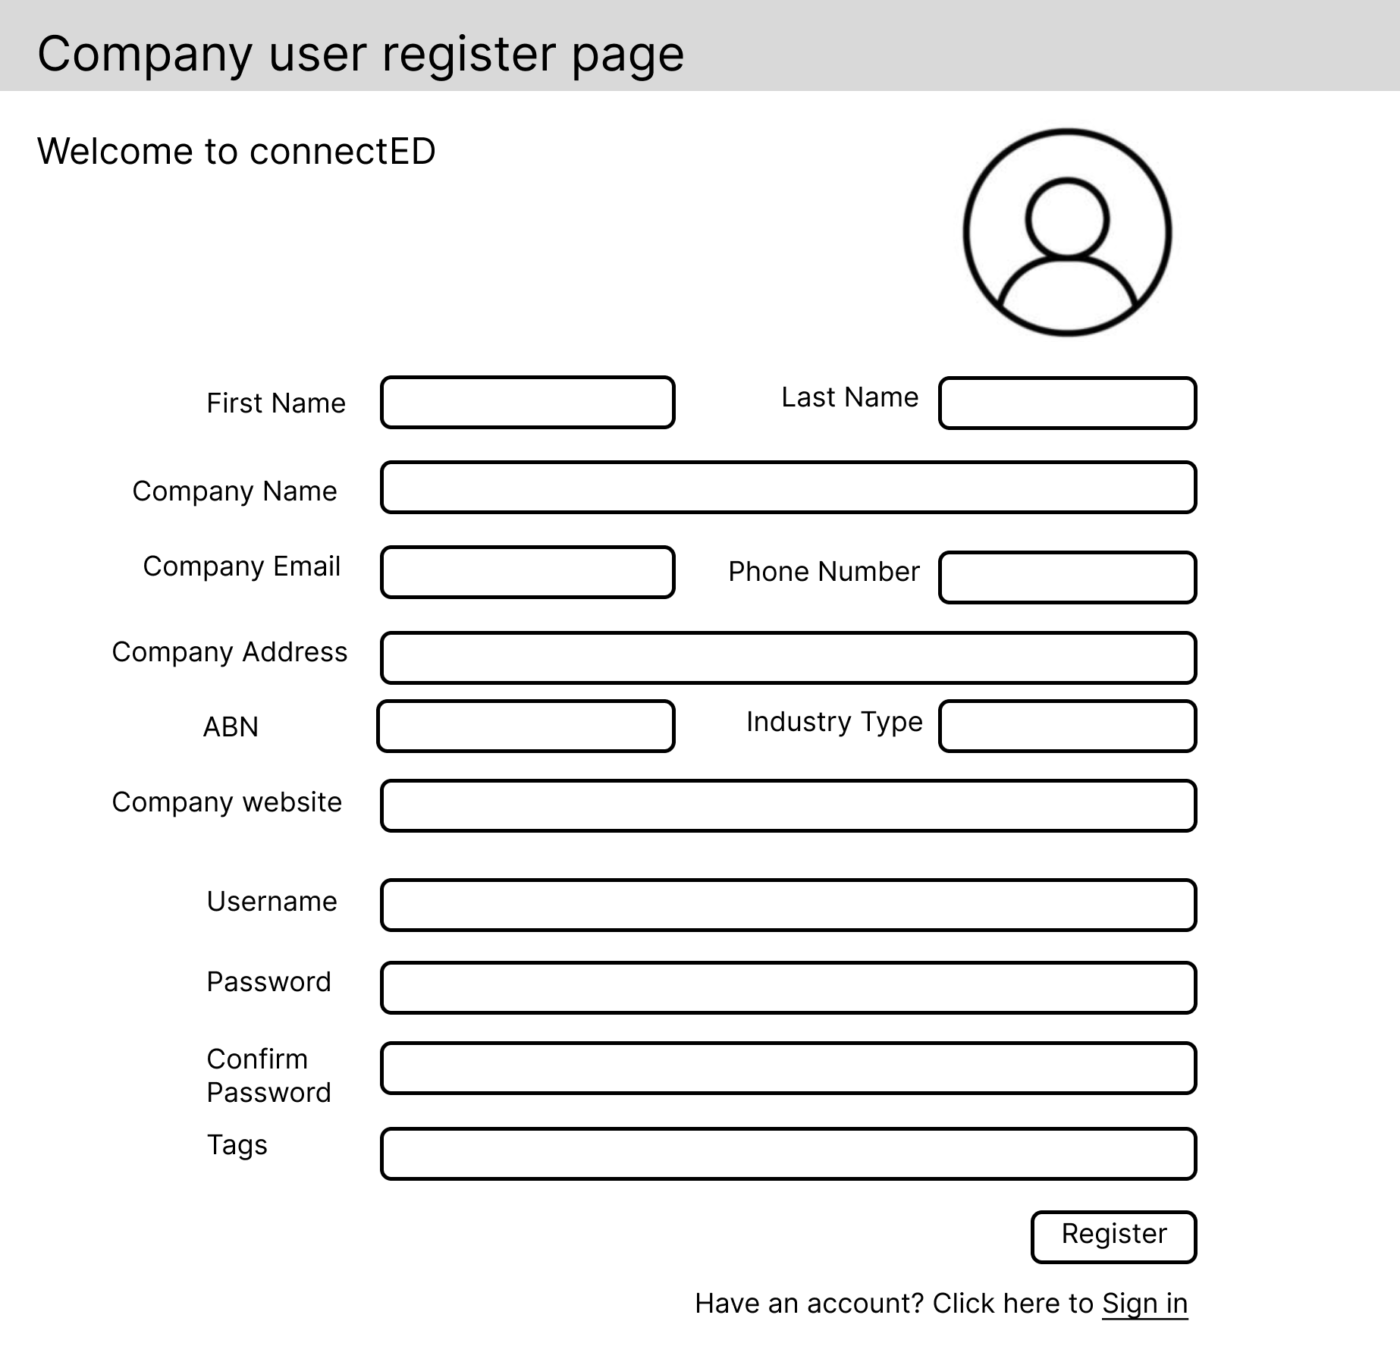

Visitor clicks Sign In

Visitor clicks

Register

Company user clicks Sign In

Visitor clicks register and become a company user

### View Profile and Logout

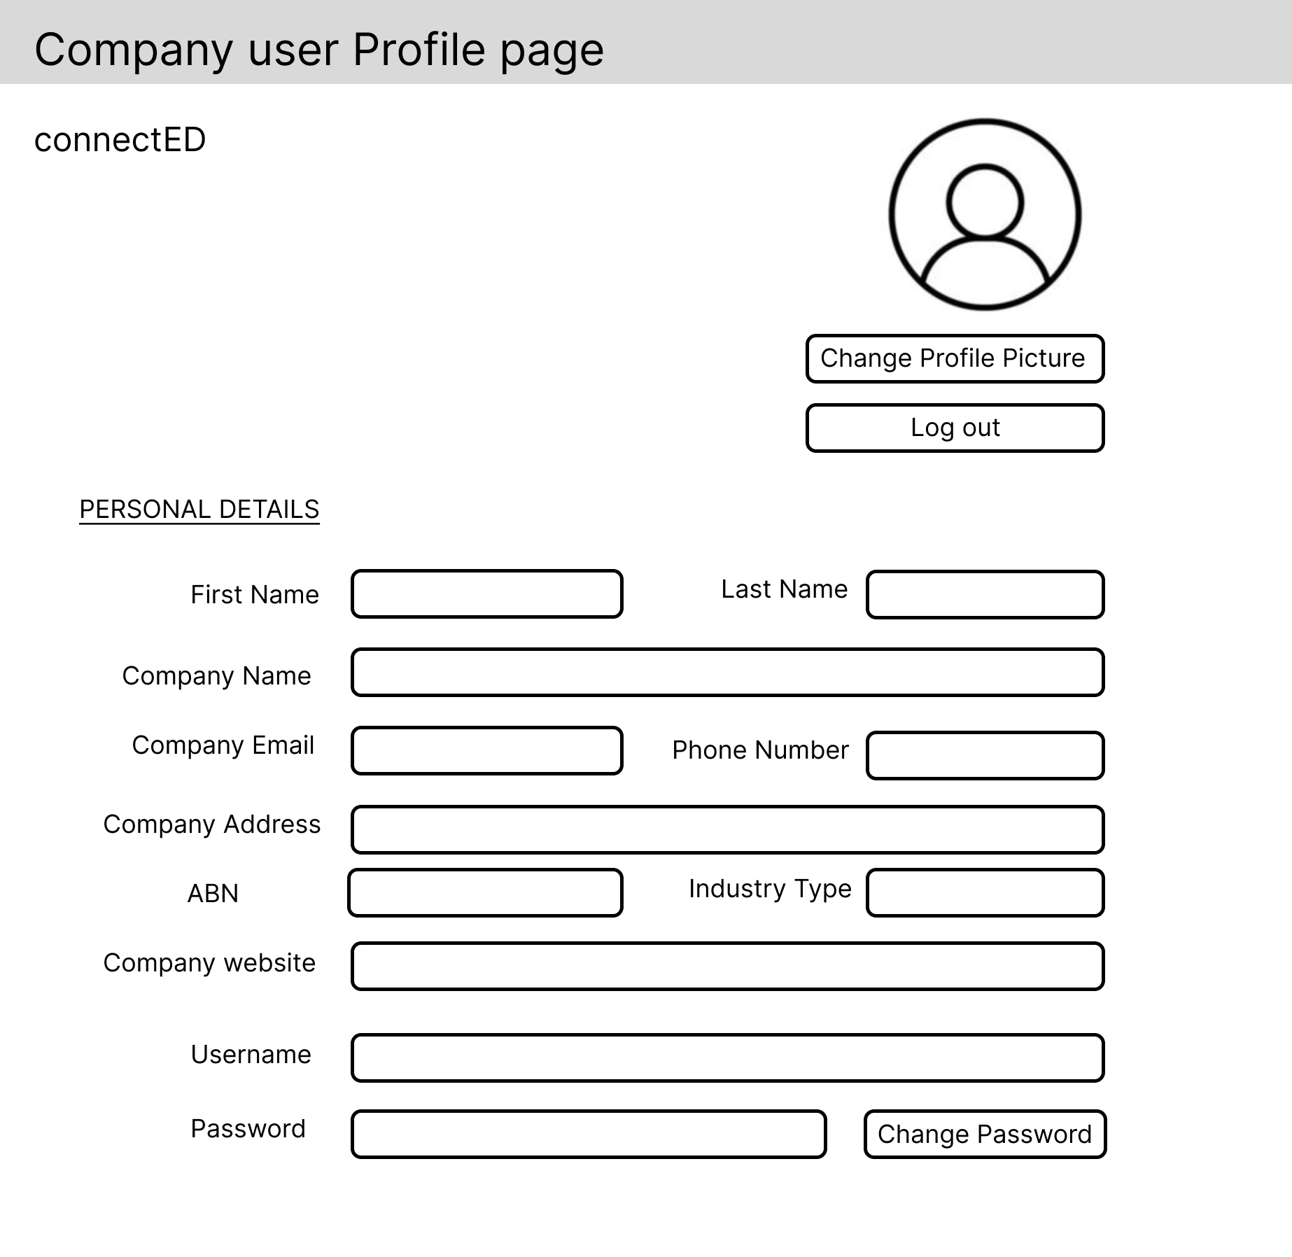

Company User clicks profile

Company user clicks log out

Company user clicks log out

### Create New Project, View Projects, and Edit Existing New Project

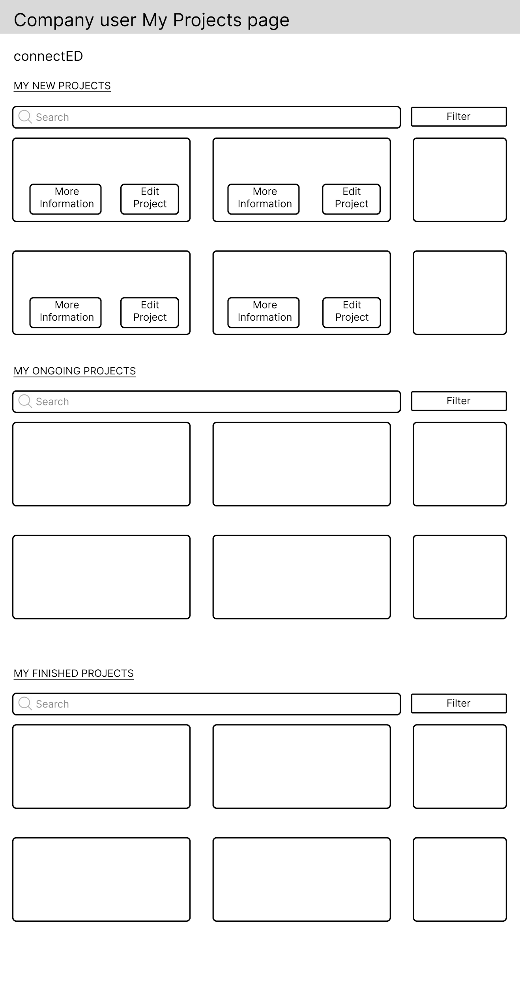

Company user clicks create new project button

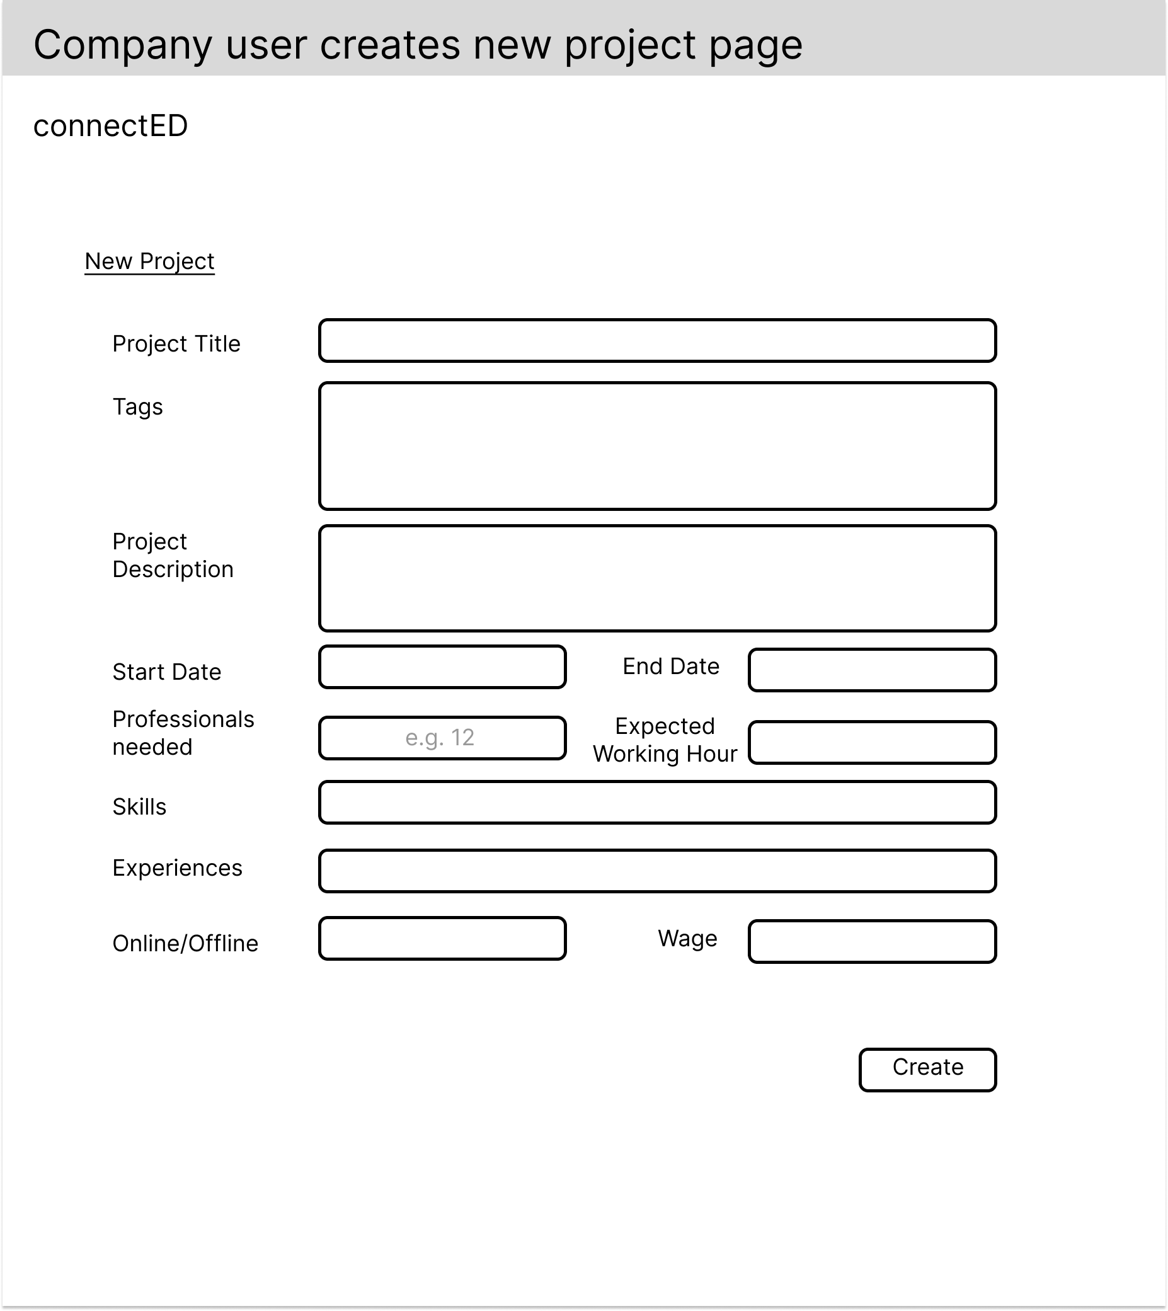

Company user clicks My Projects button

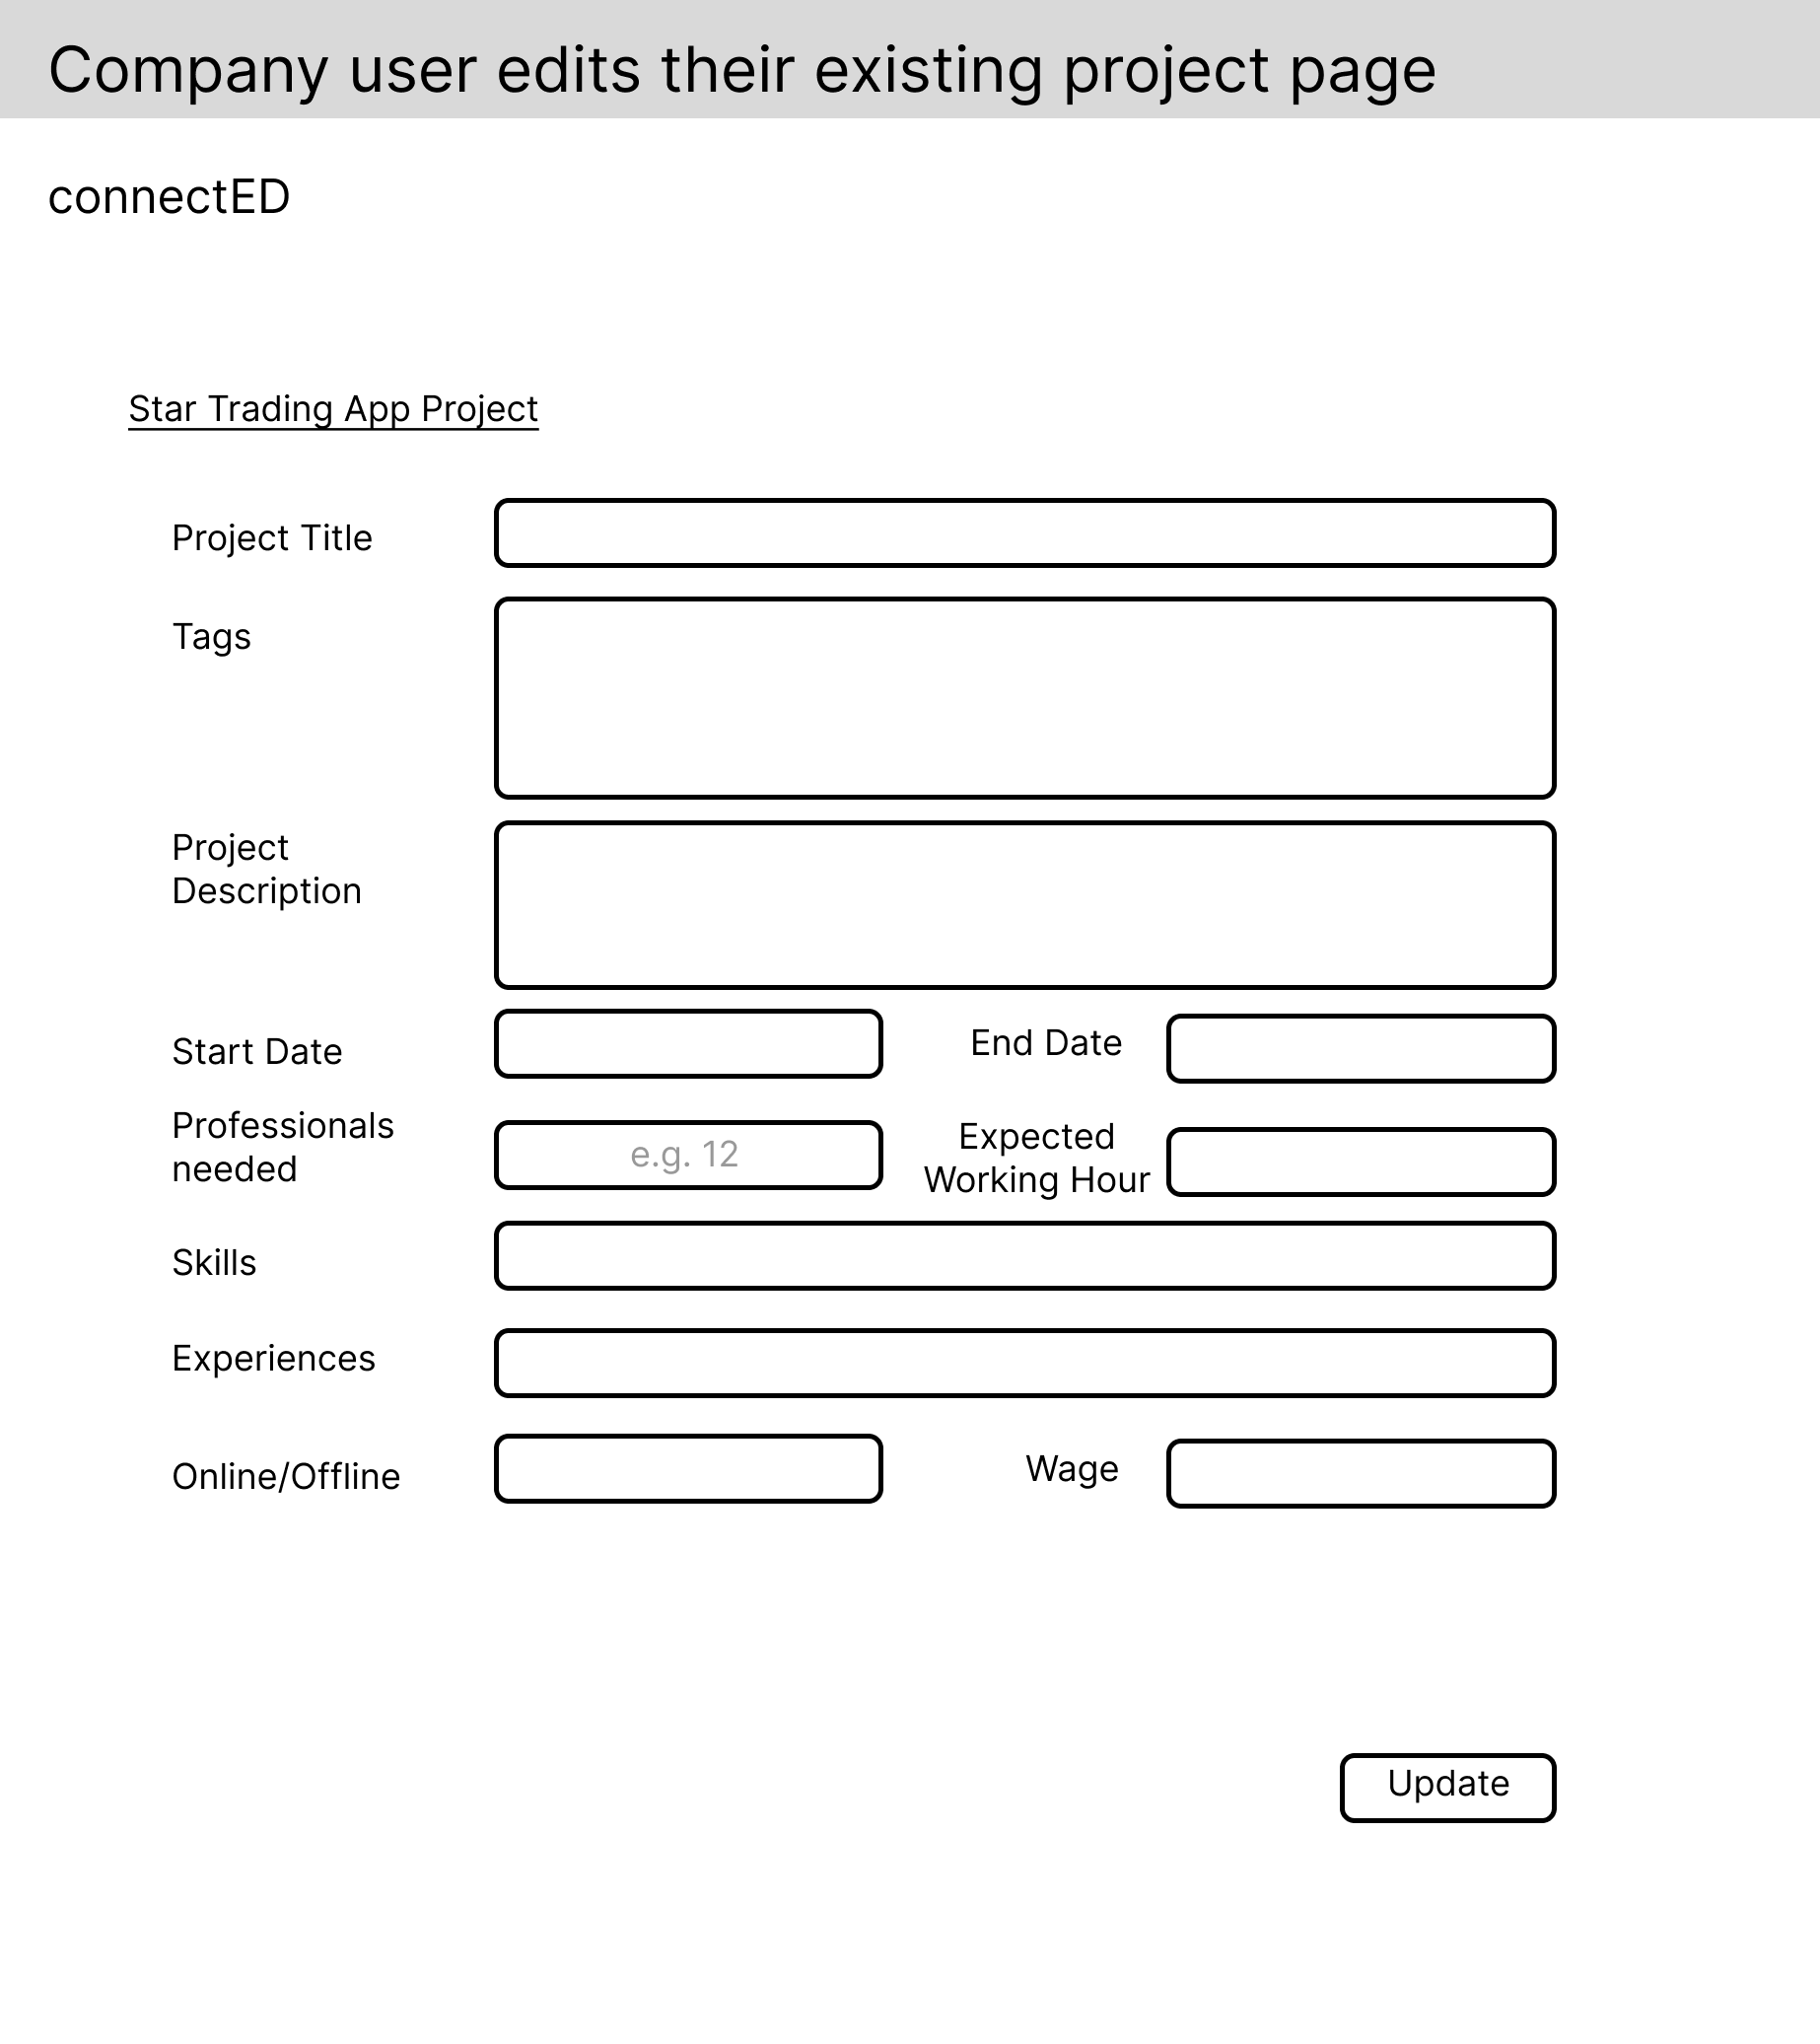

Company user clicks edit project

### Manage Professionals in Projects

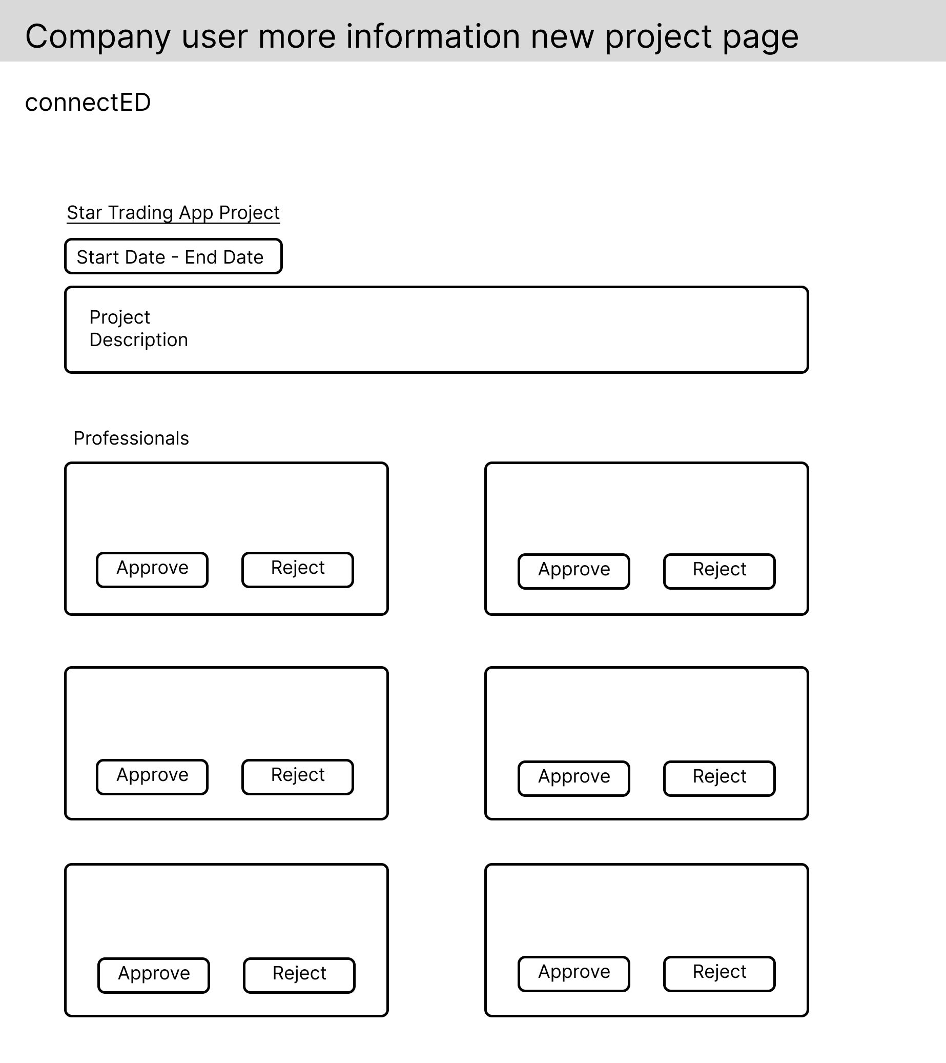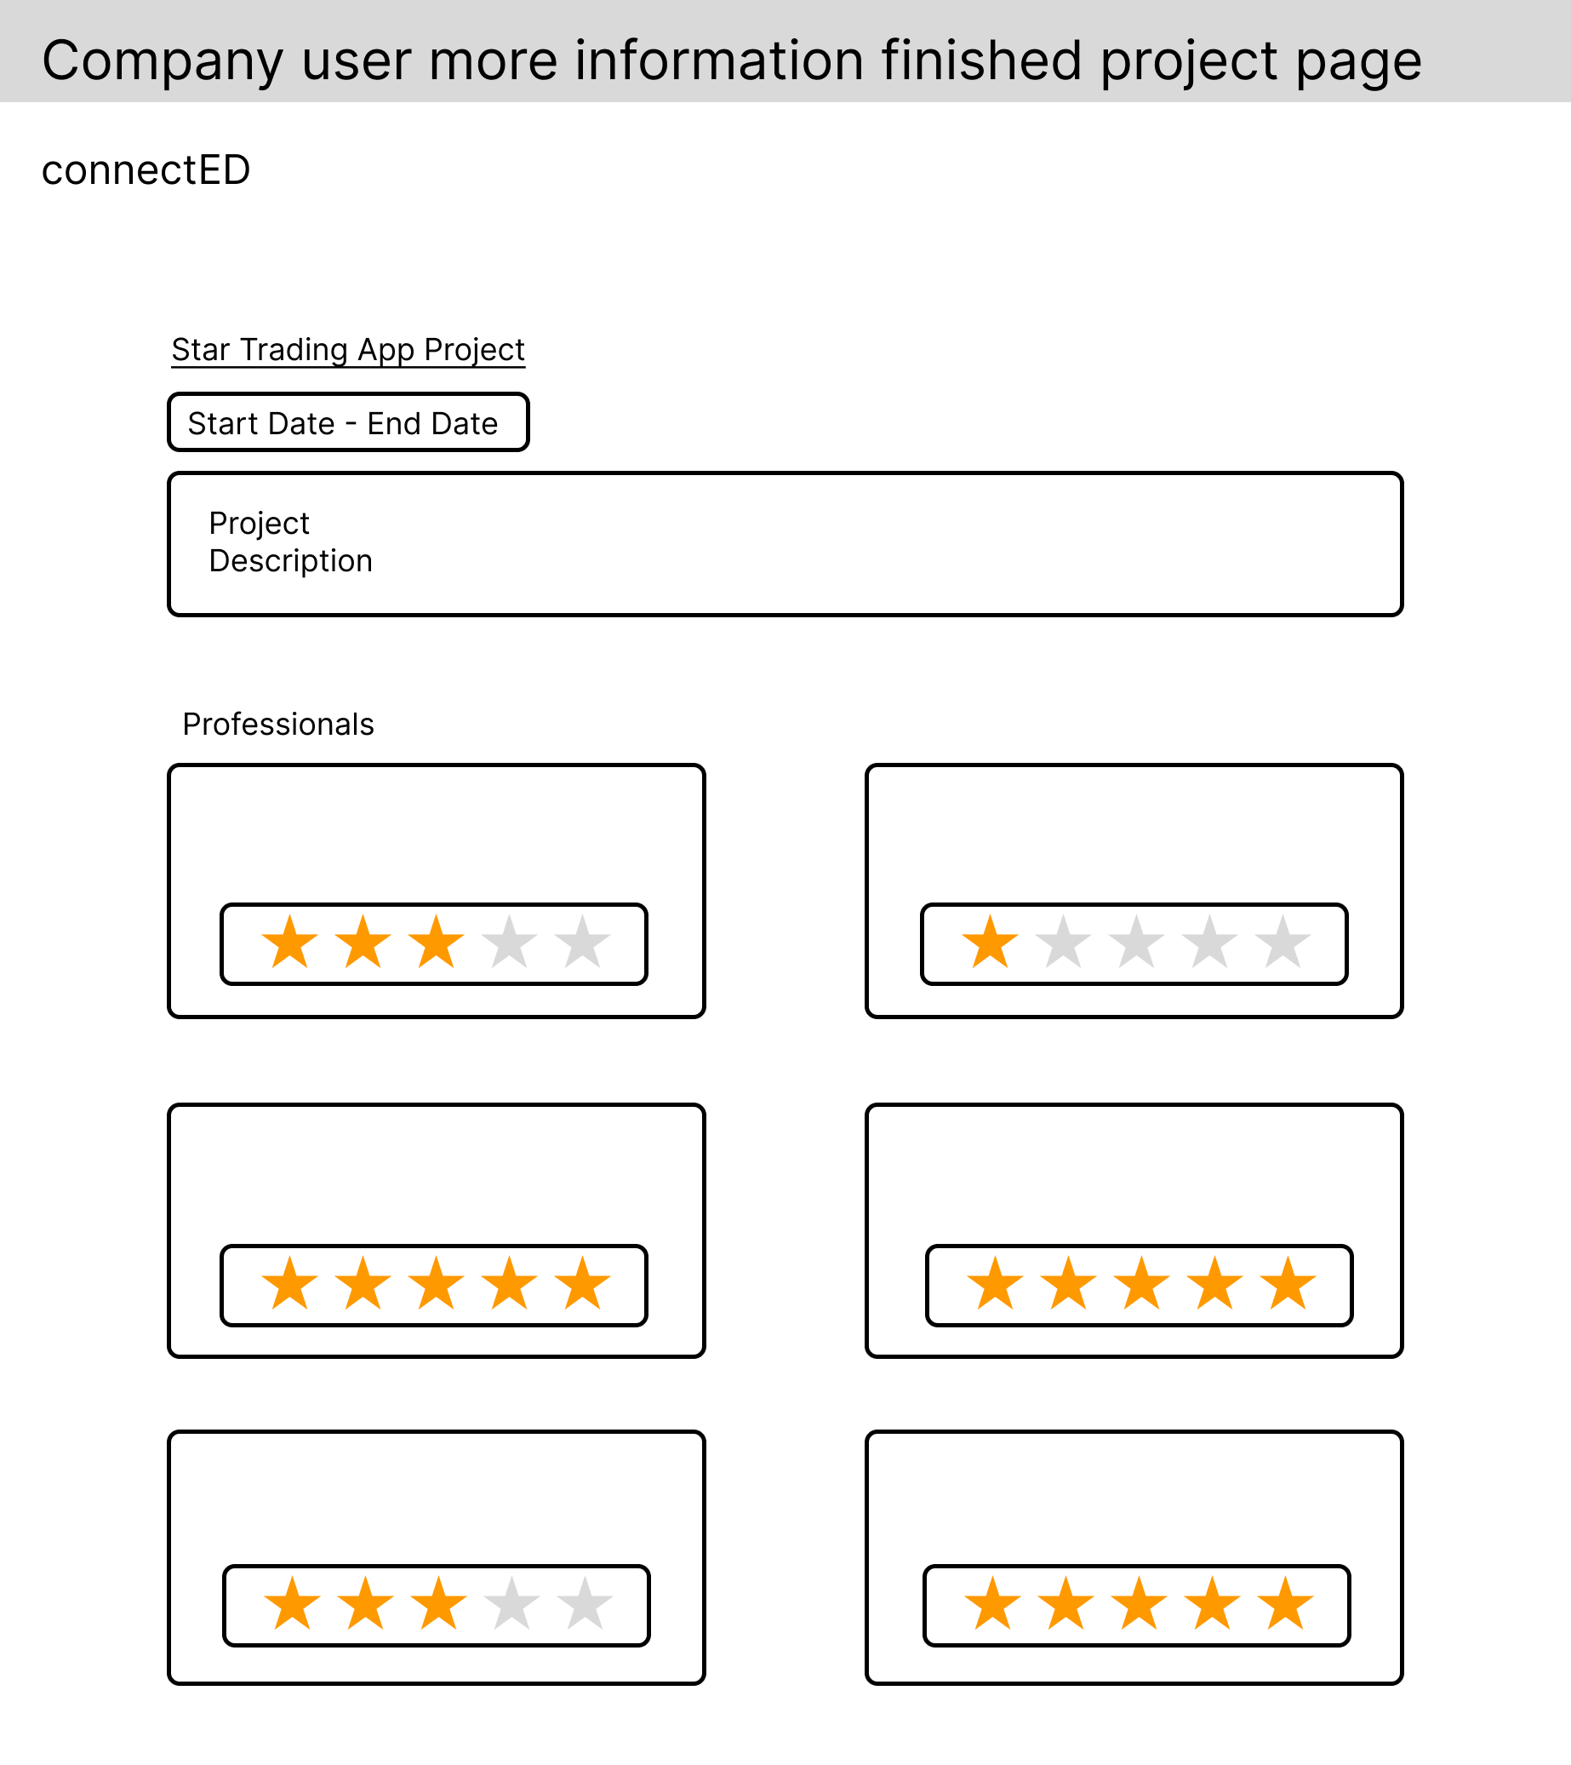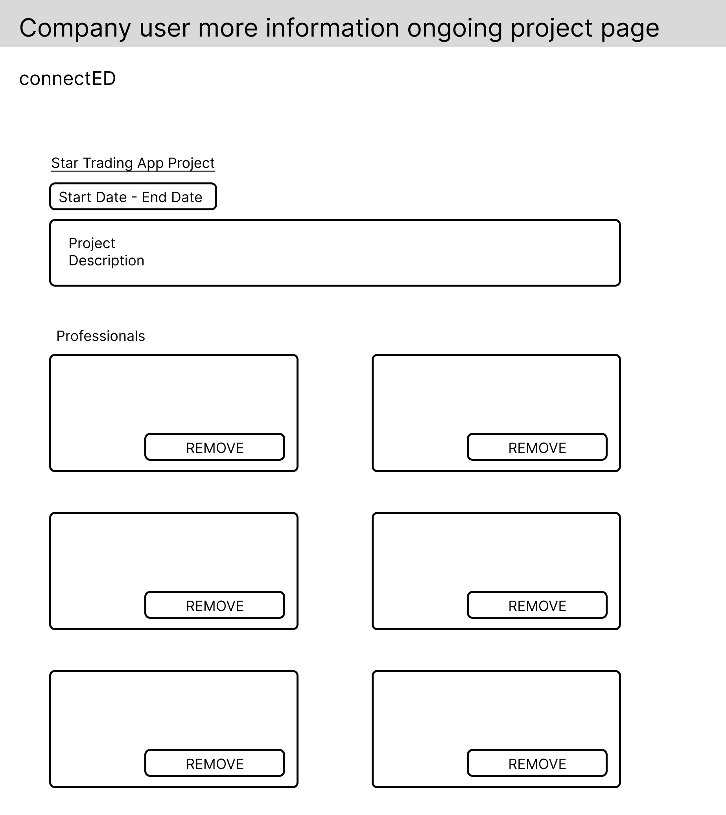

Company user clicks more information button of a new project - approve/reject professionals

Company user clicks more information button of an ongoing project - remove professionals

Company user clicks more information button of a finished project - allowed rating professionals when project is done

### View Professional User Profile

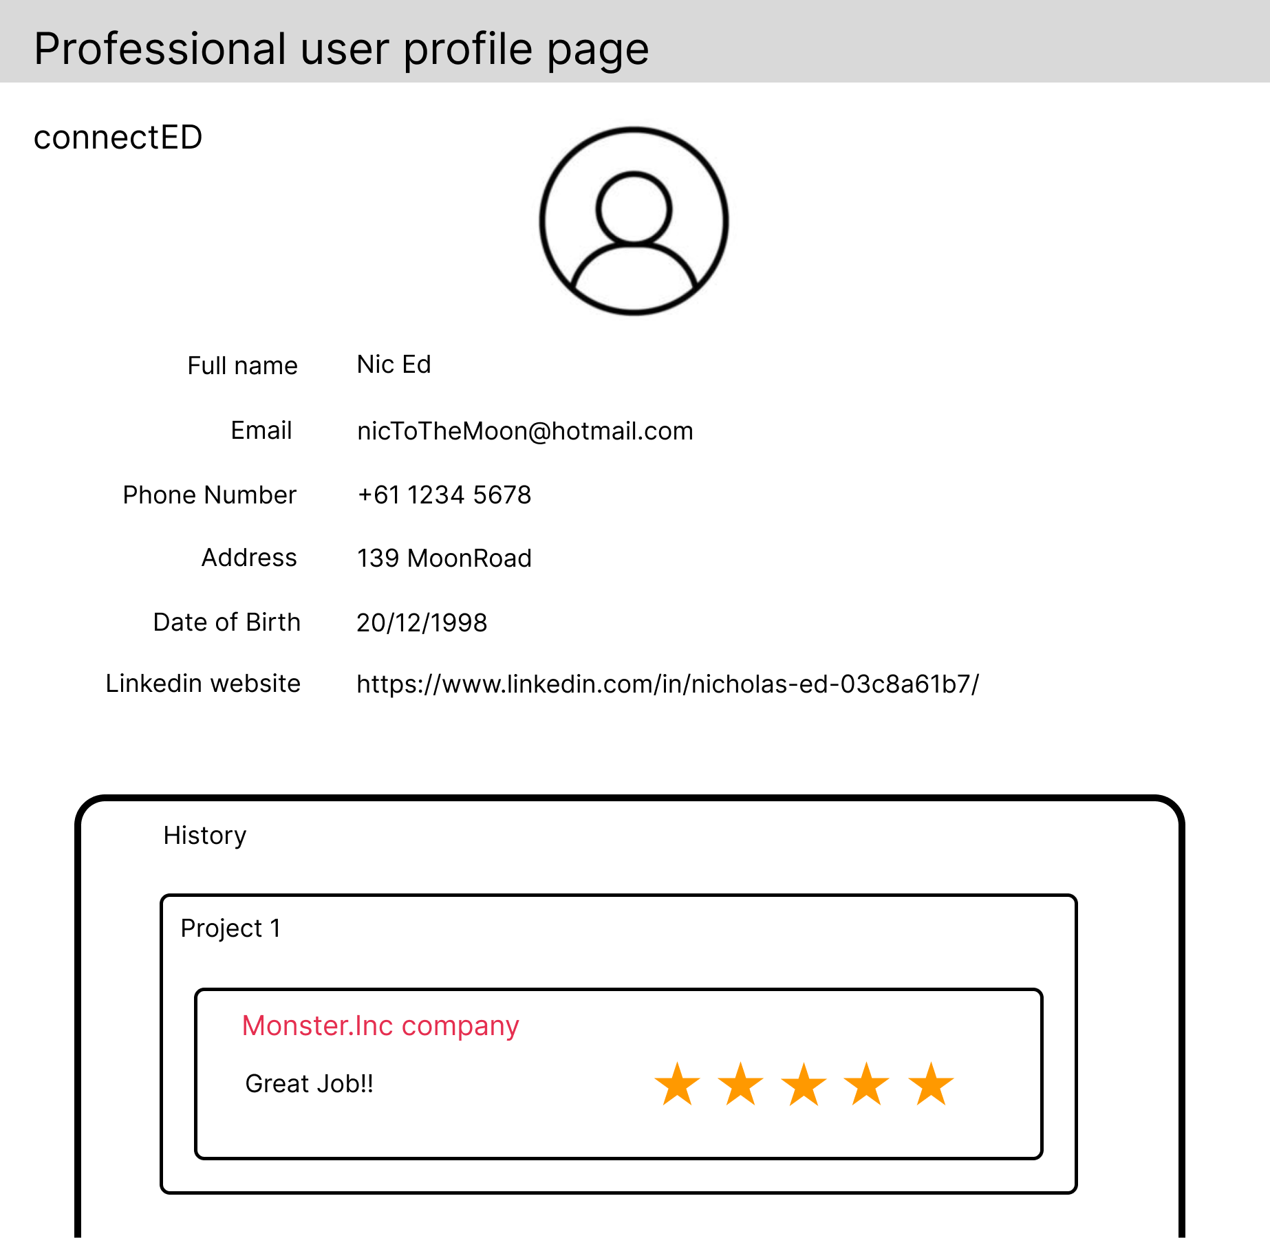

Company user clicks professional’s card to see their profile

Company user clicks professional’s card to see their profile

Company user clicks professional’s card to see their profile

## Professional Storyboard

### Login and Register

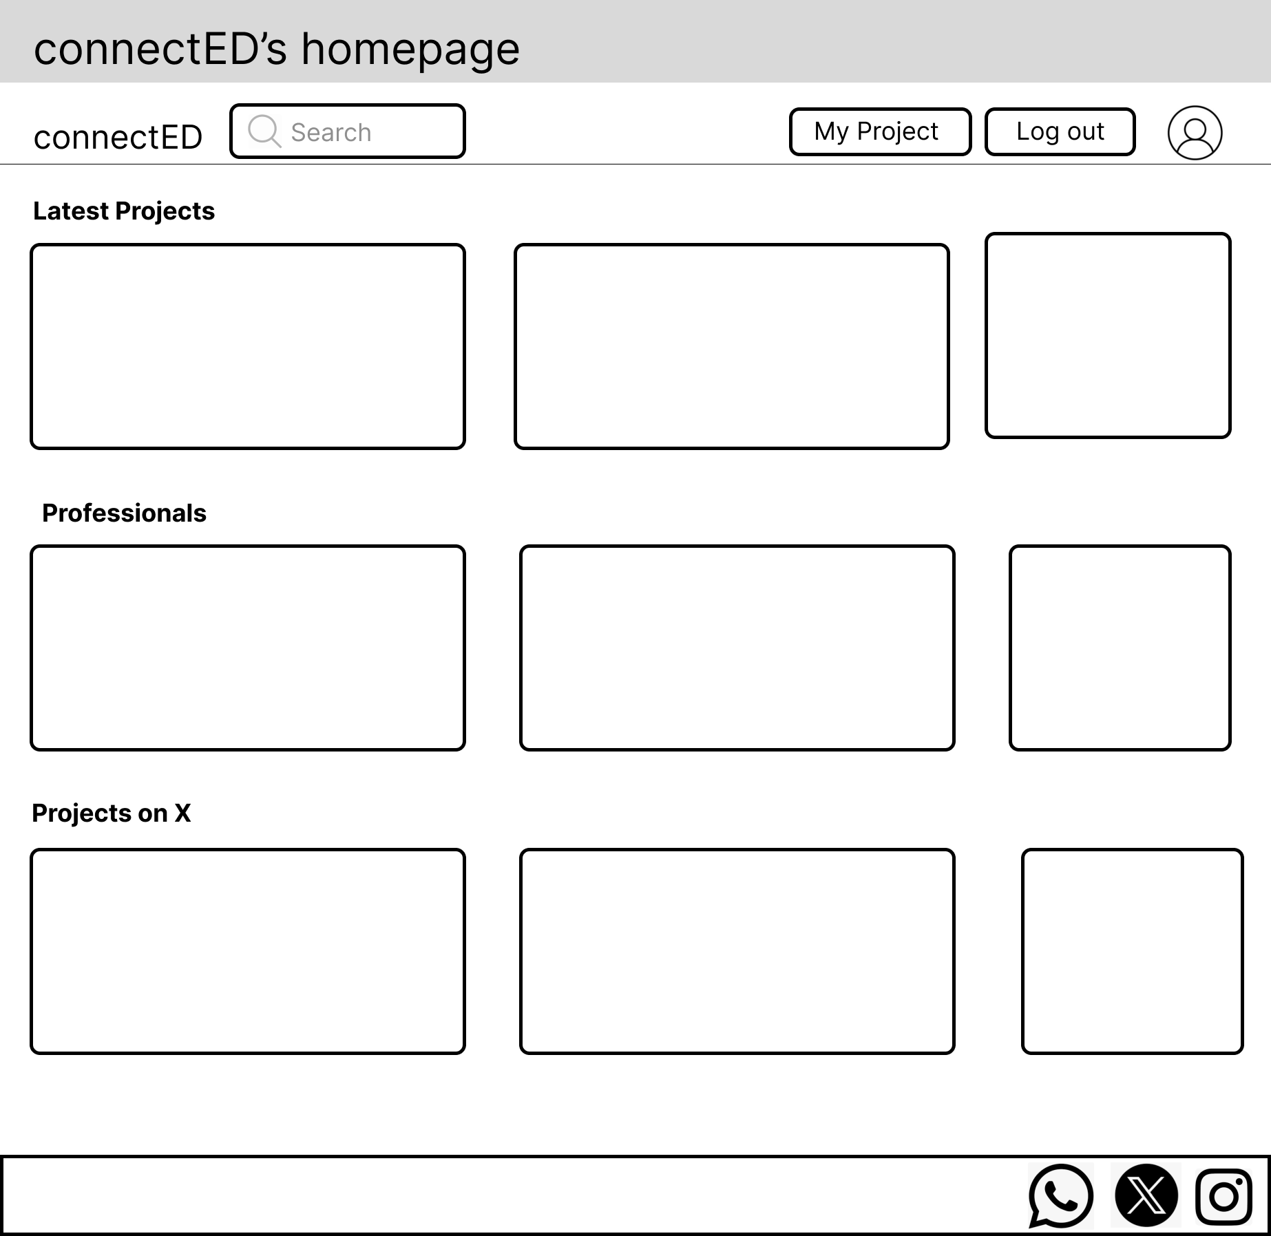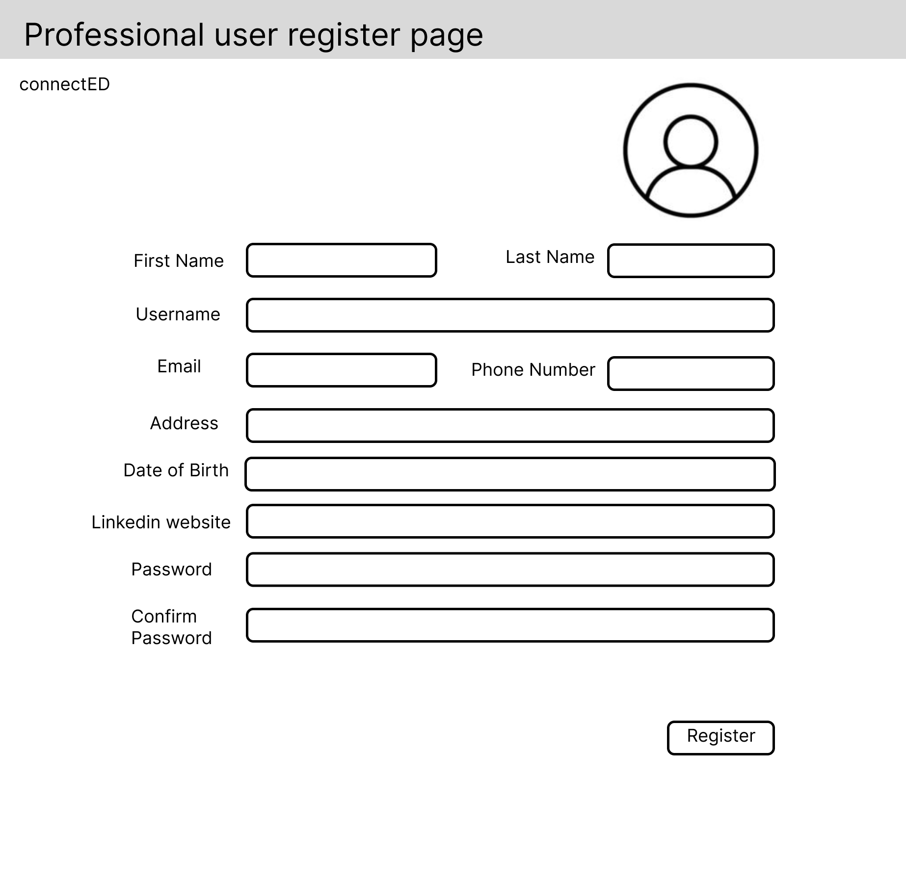

Visitor clicks register

Visitor clicks

Login

Visitor clicks register

Visitor clicks professional user

User successfully signs in and goes to homepage

User Finish registering and goes to homepage

### View/Edit profile, View Other Professional Profile, and Logout

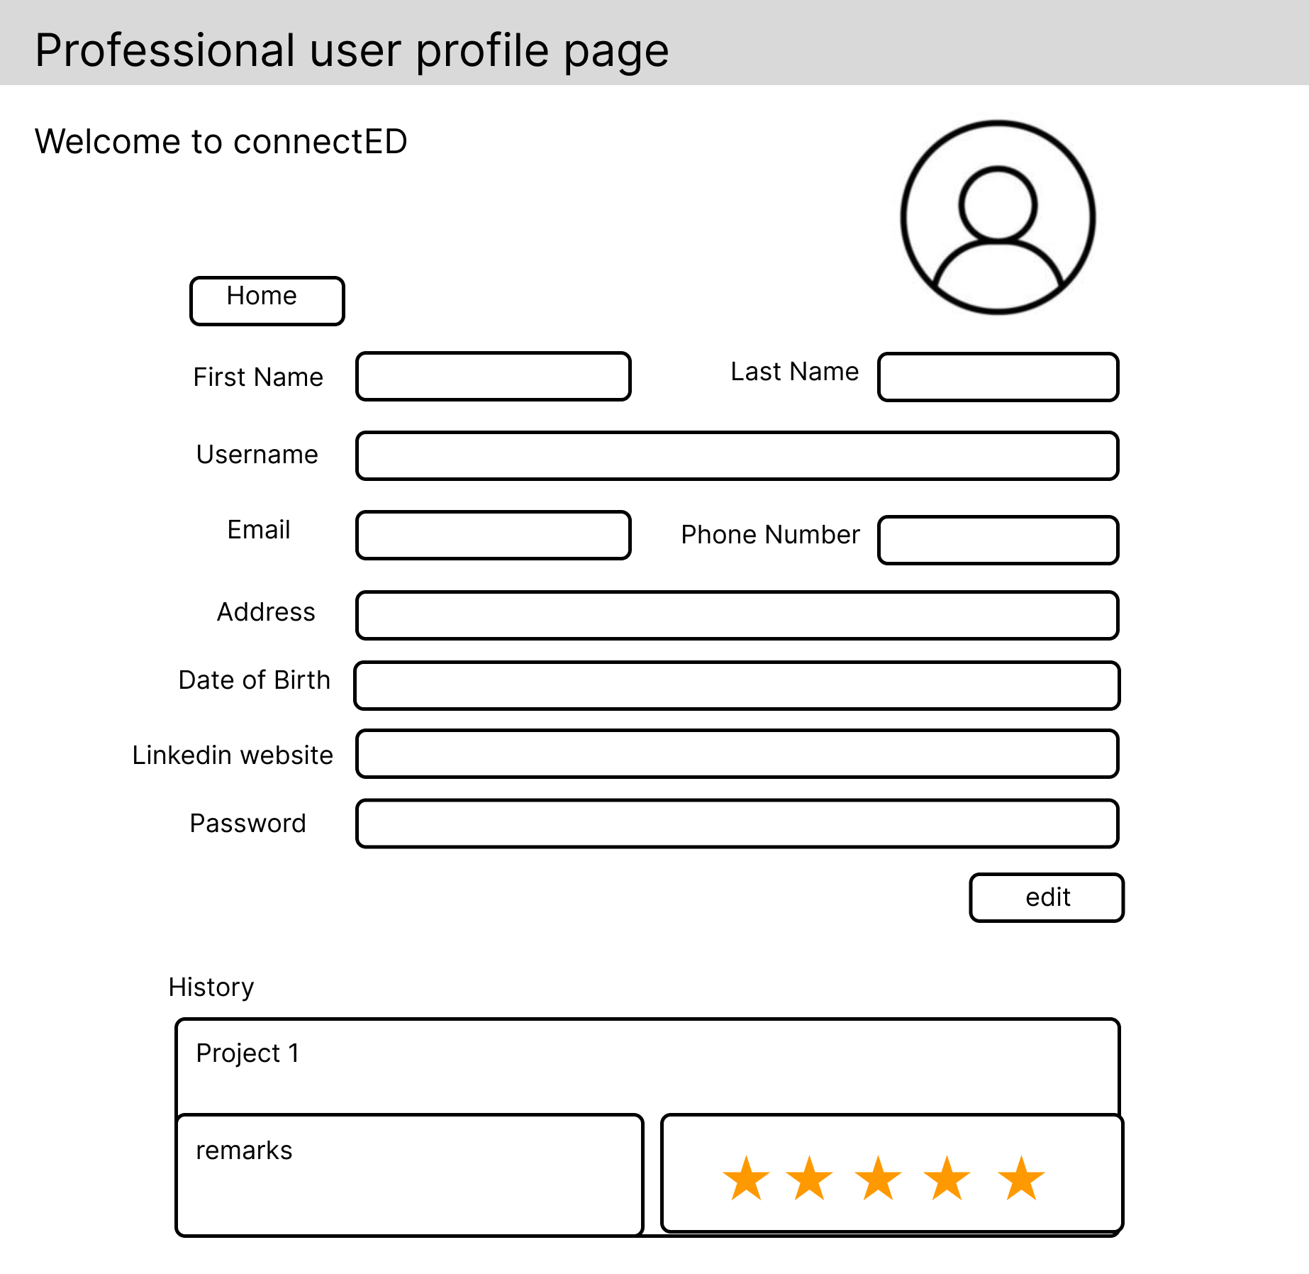

Professional User clicks the profile icon to go profile page to edit the profile

Professional User clicks Logout

Professional User clicks another Professional user’s profile

### Search Projects, View Project Profile, View Company Profile

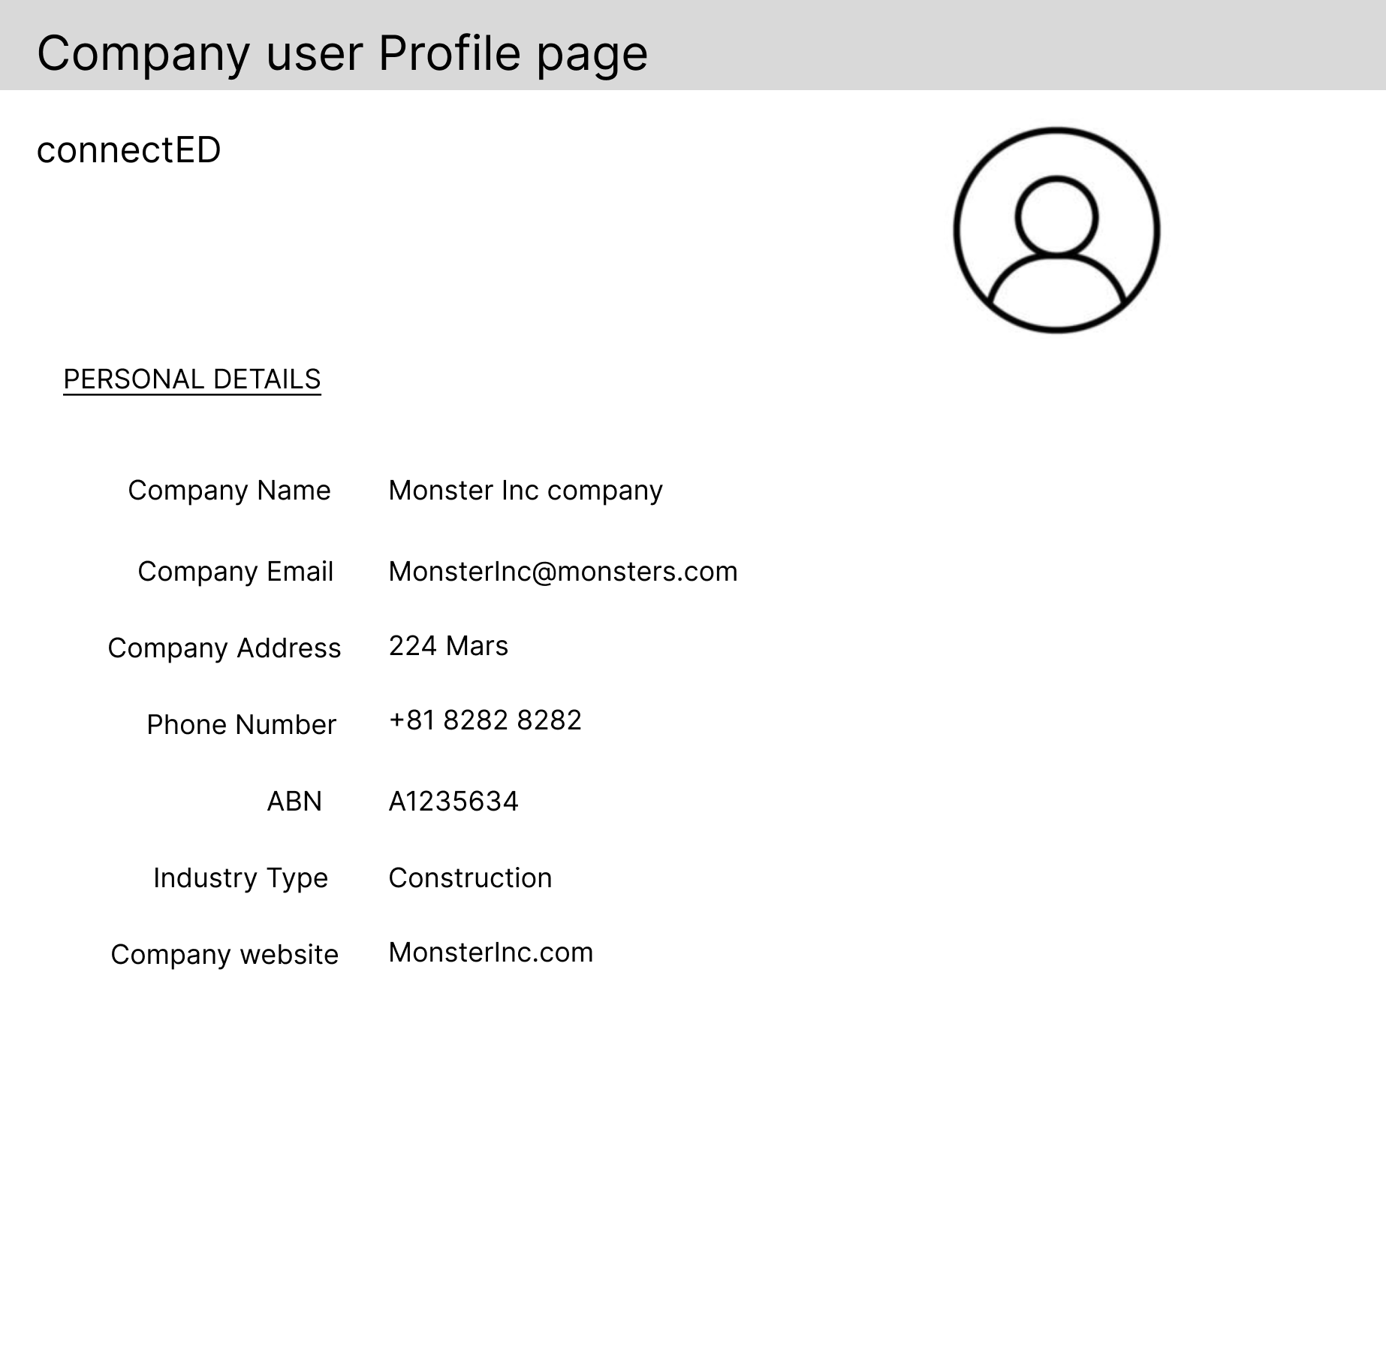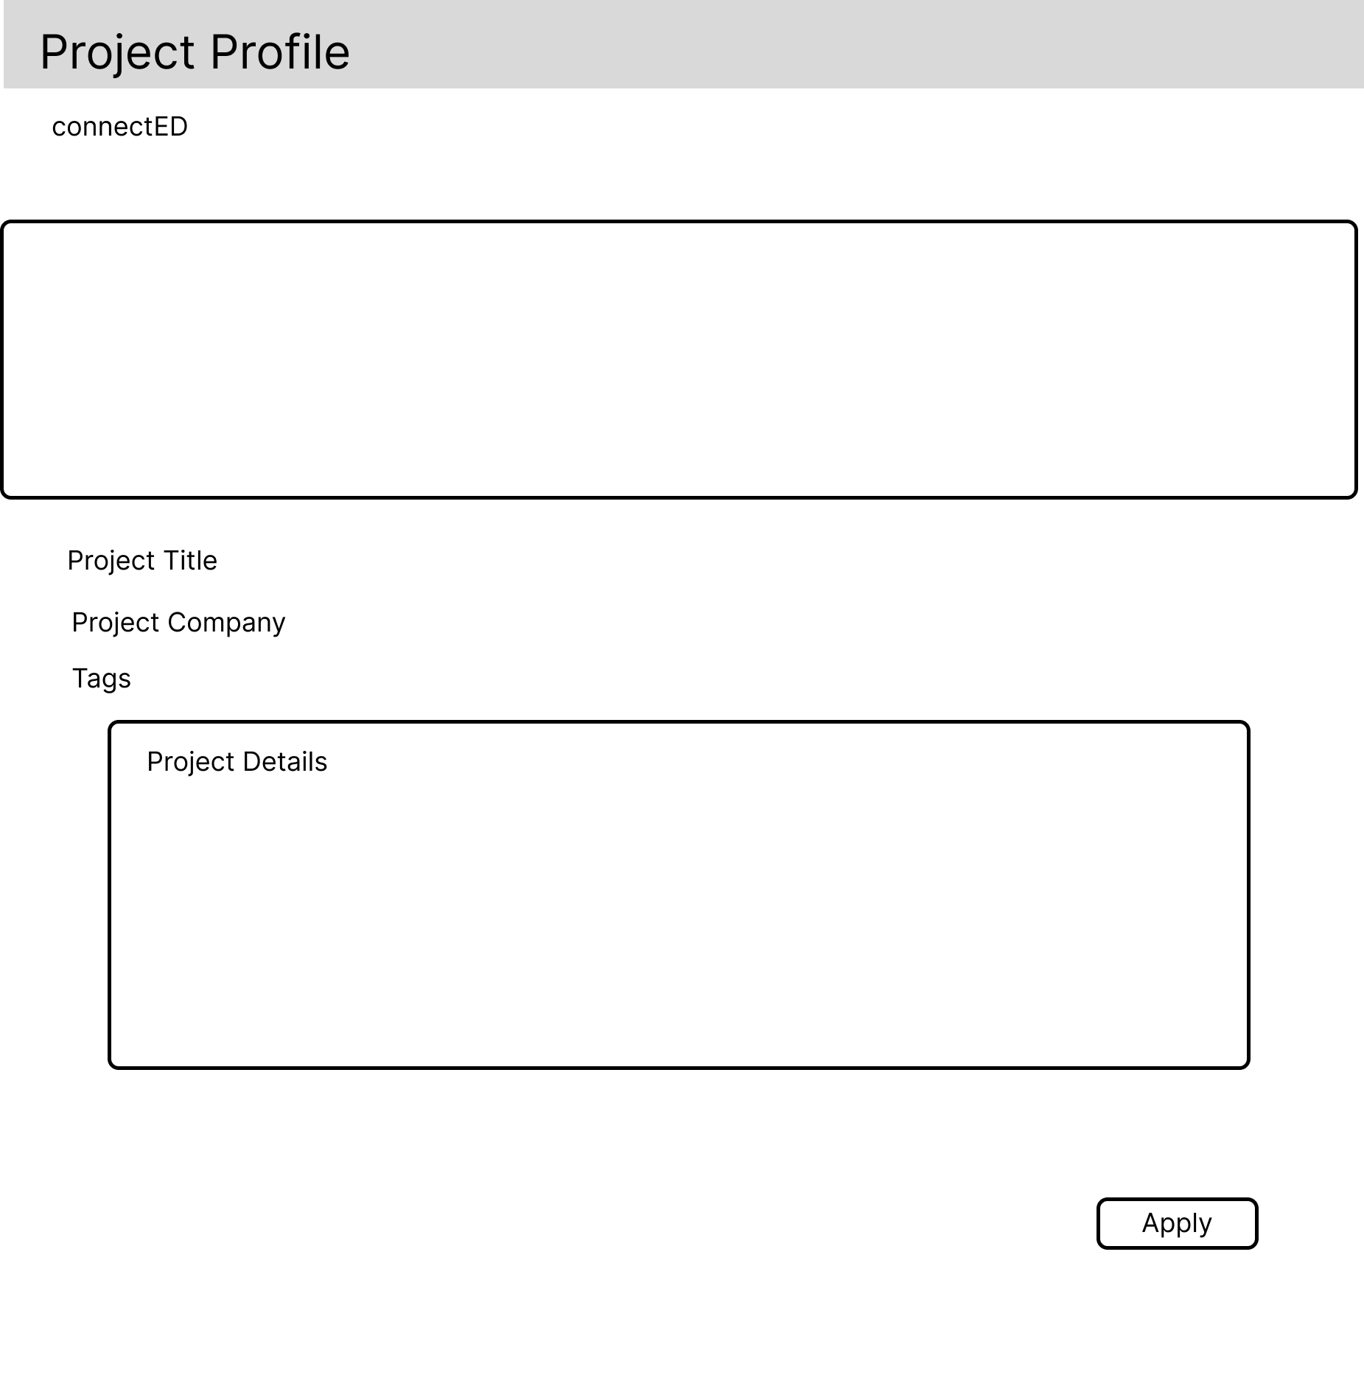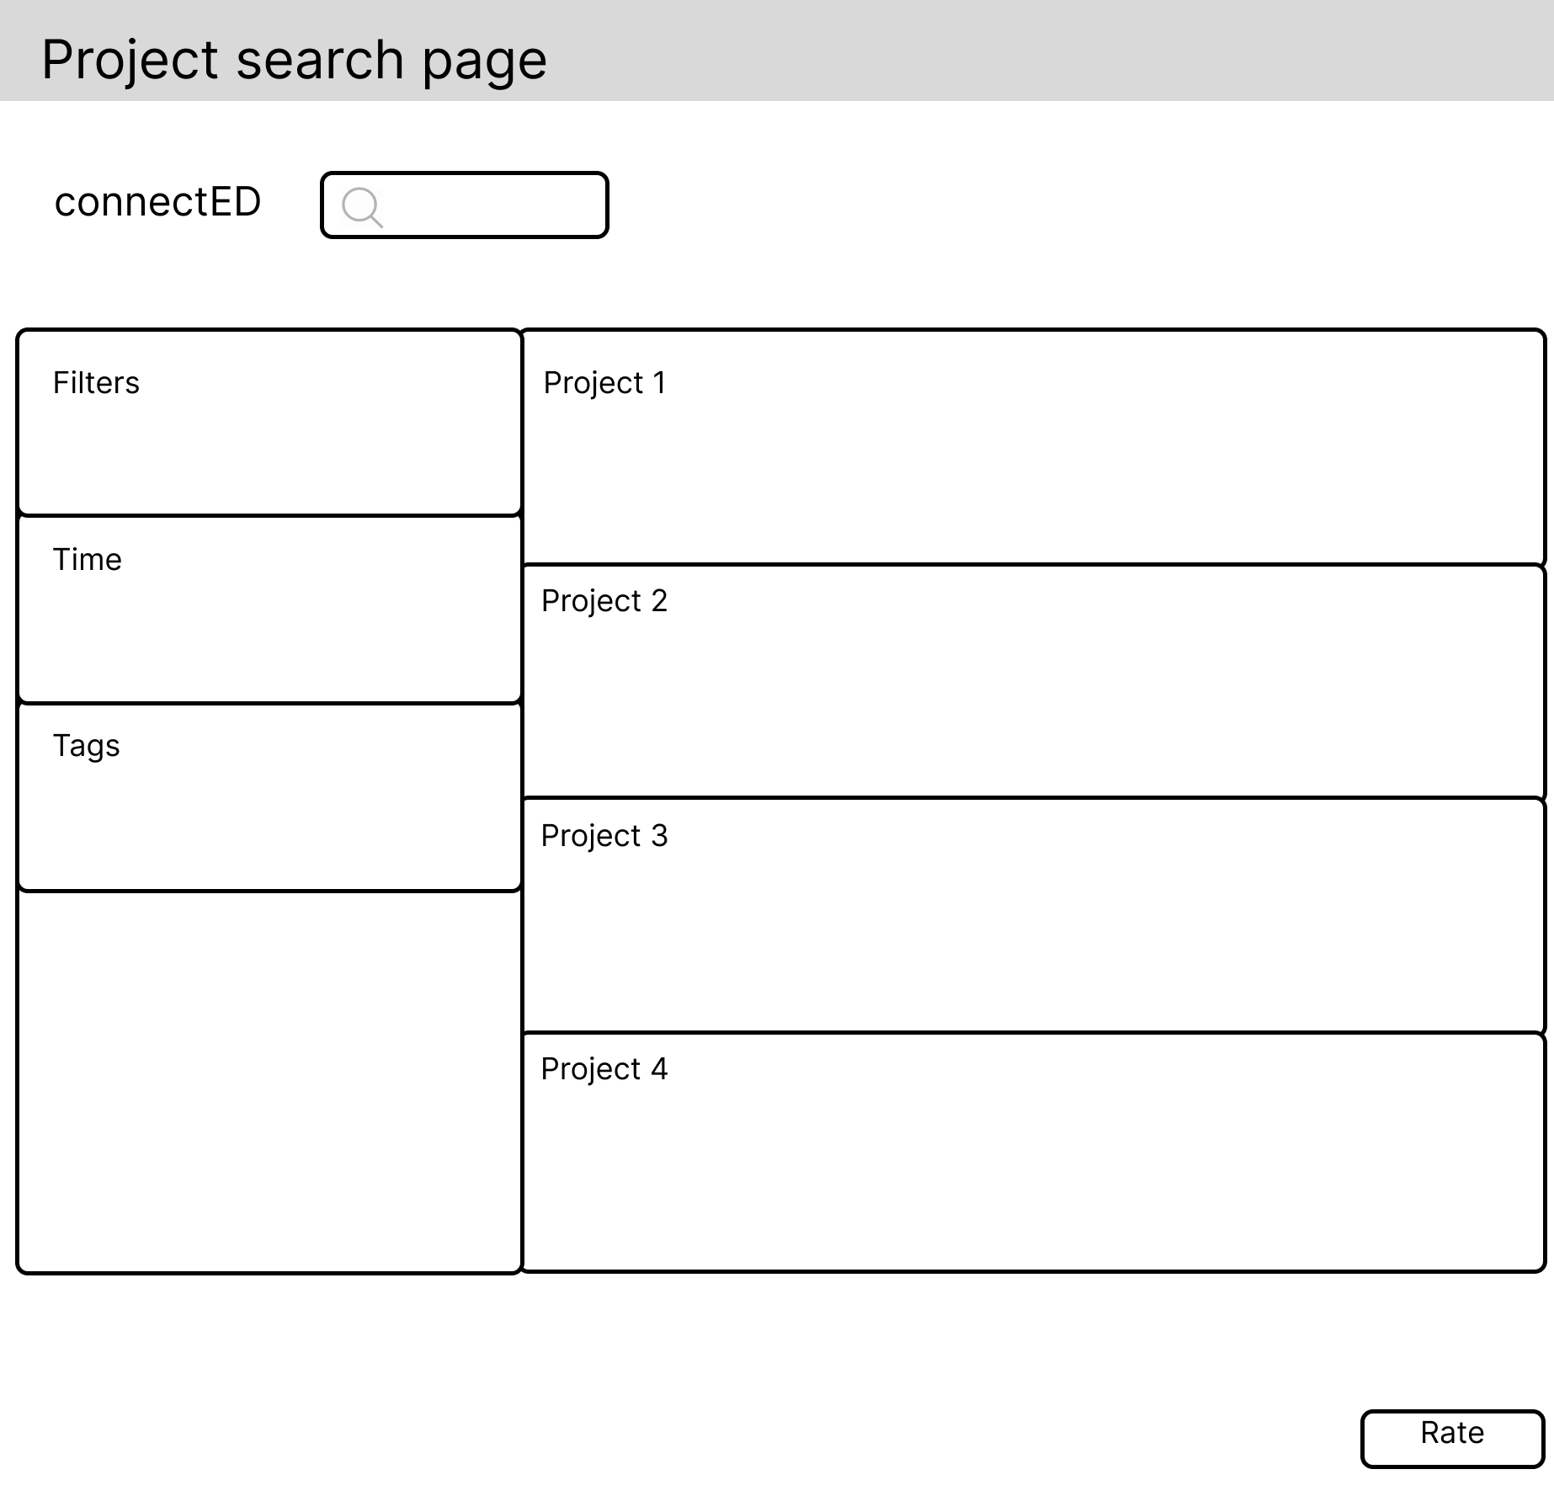

Professional User inputs a search term and clicks the search bar

Professional User clicks on one of the projects

Professional User clicks on one of the projects

Professional User checks the company profile

### Project Application, Check Project Detail, and Rating the Project Upon Completion

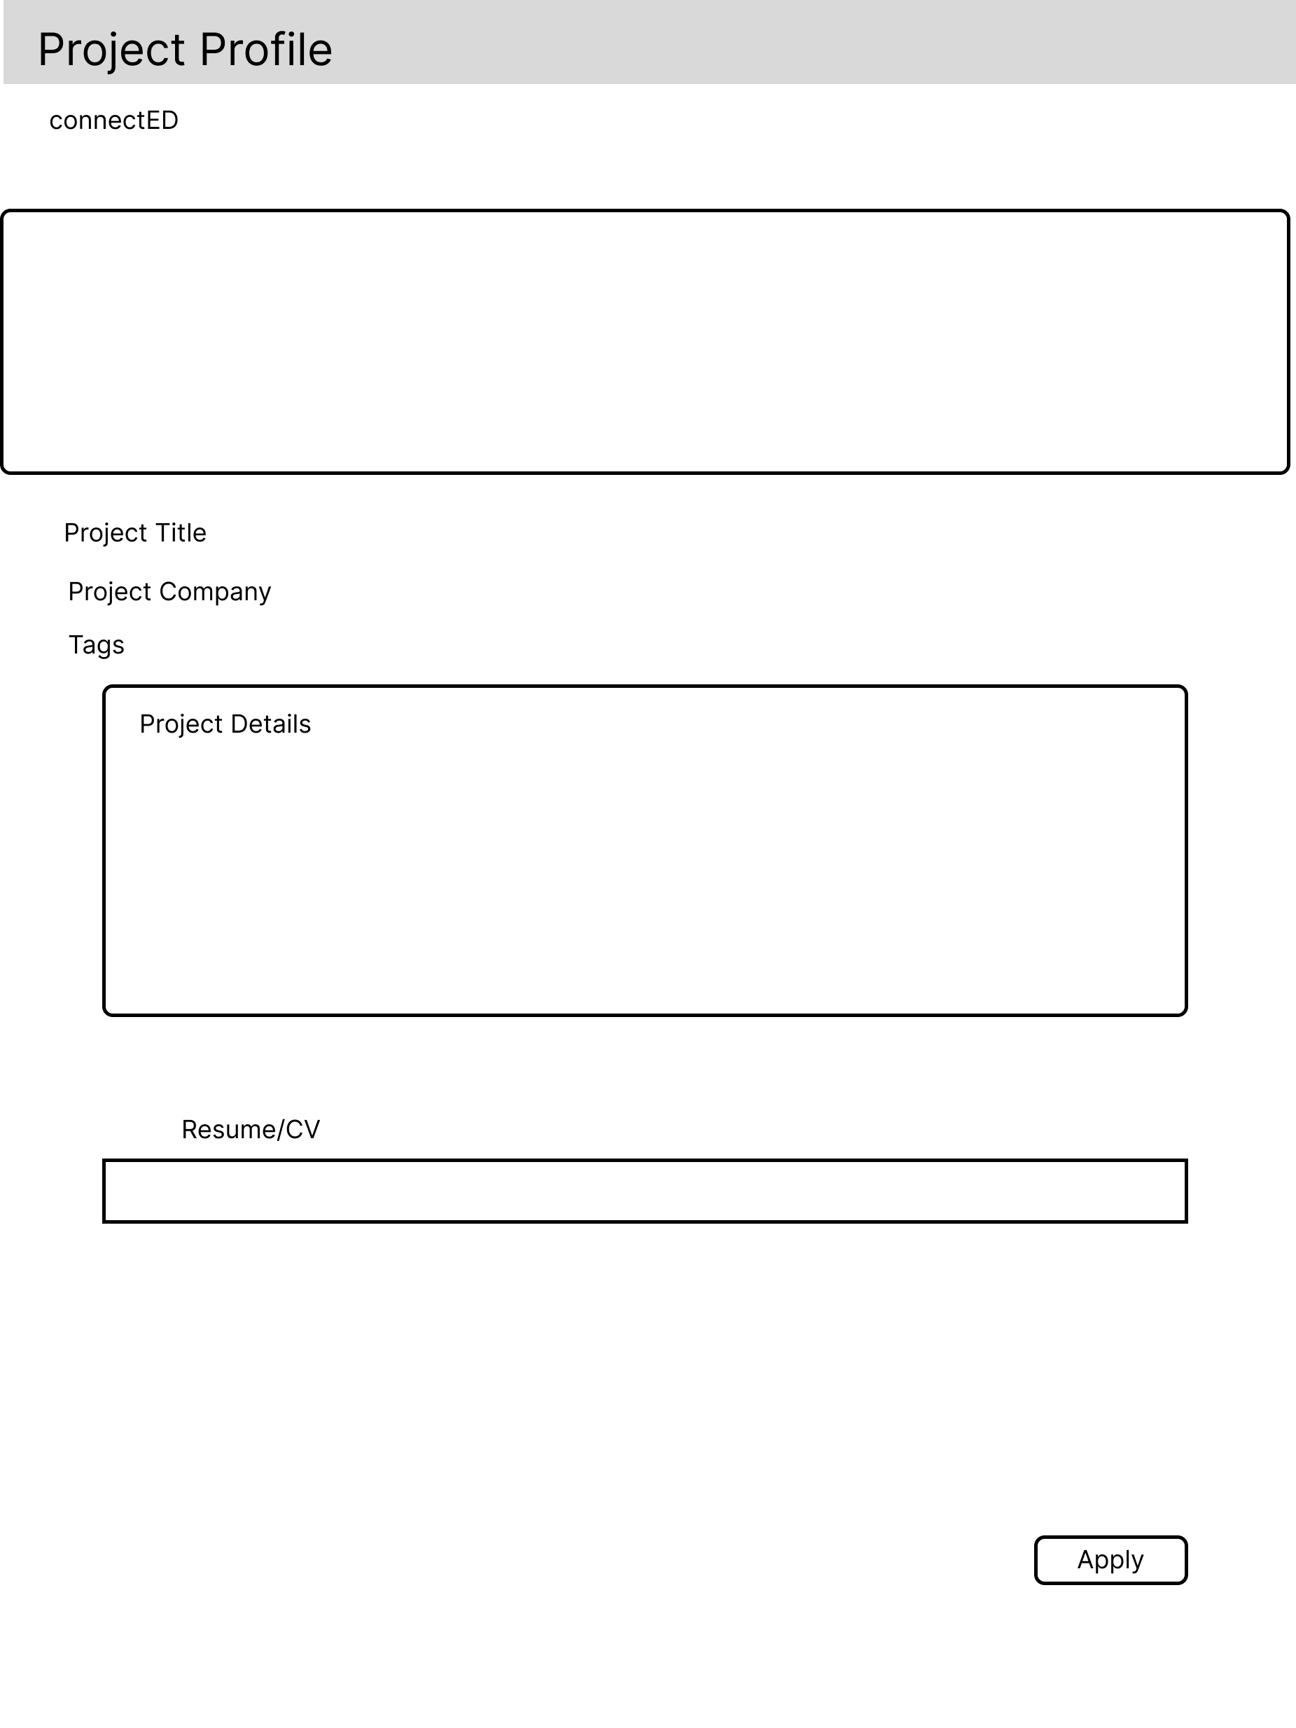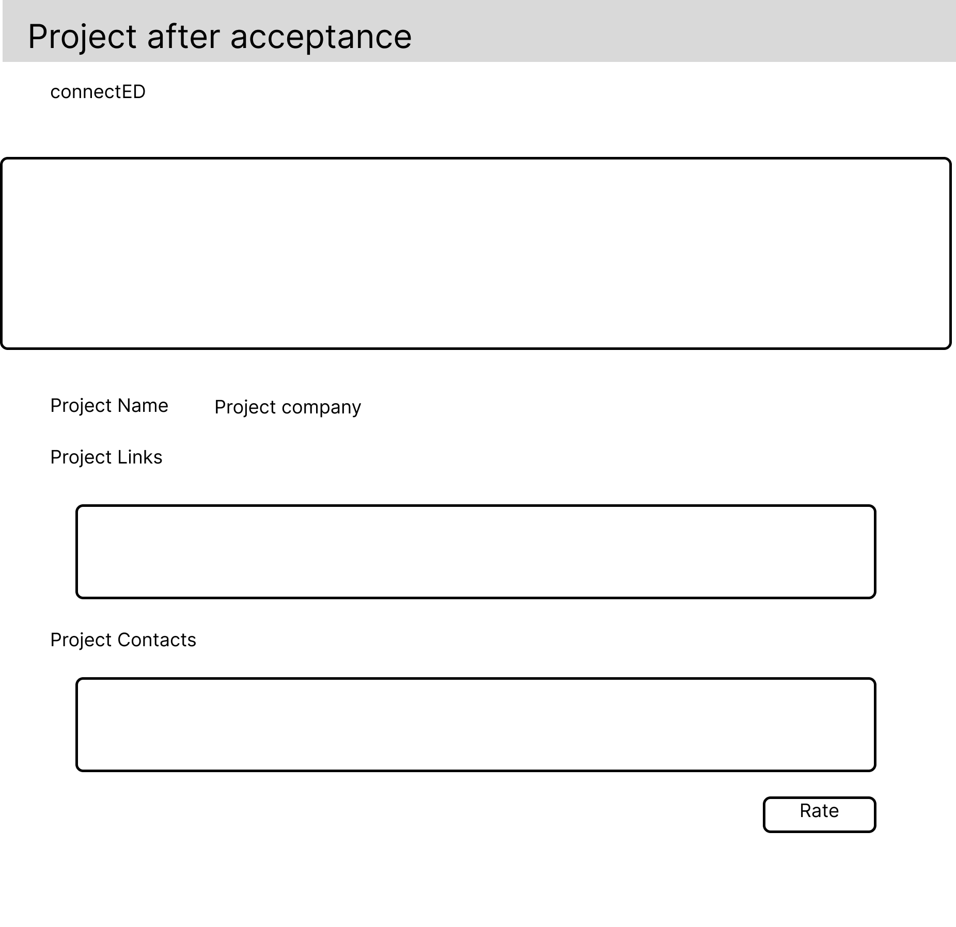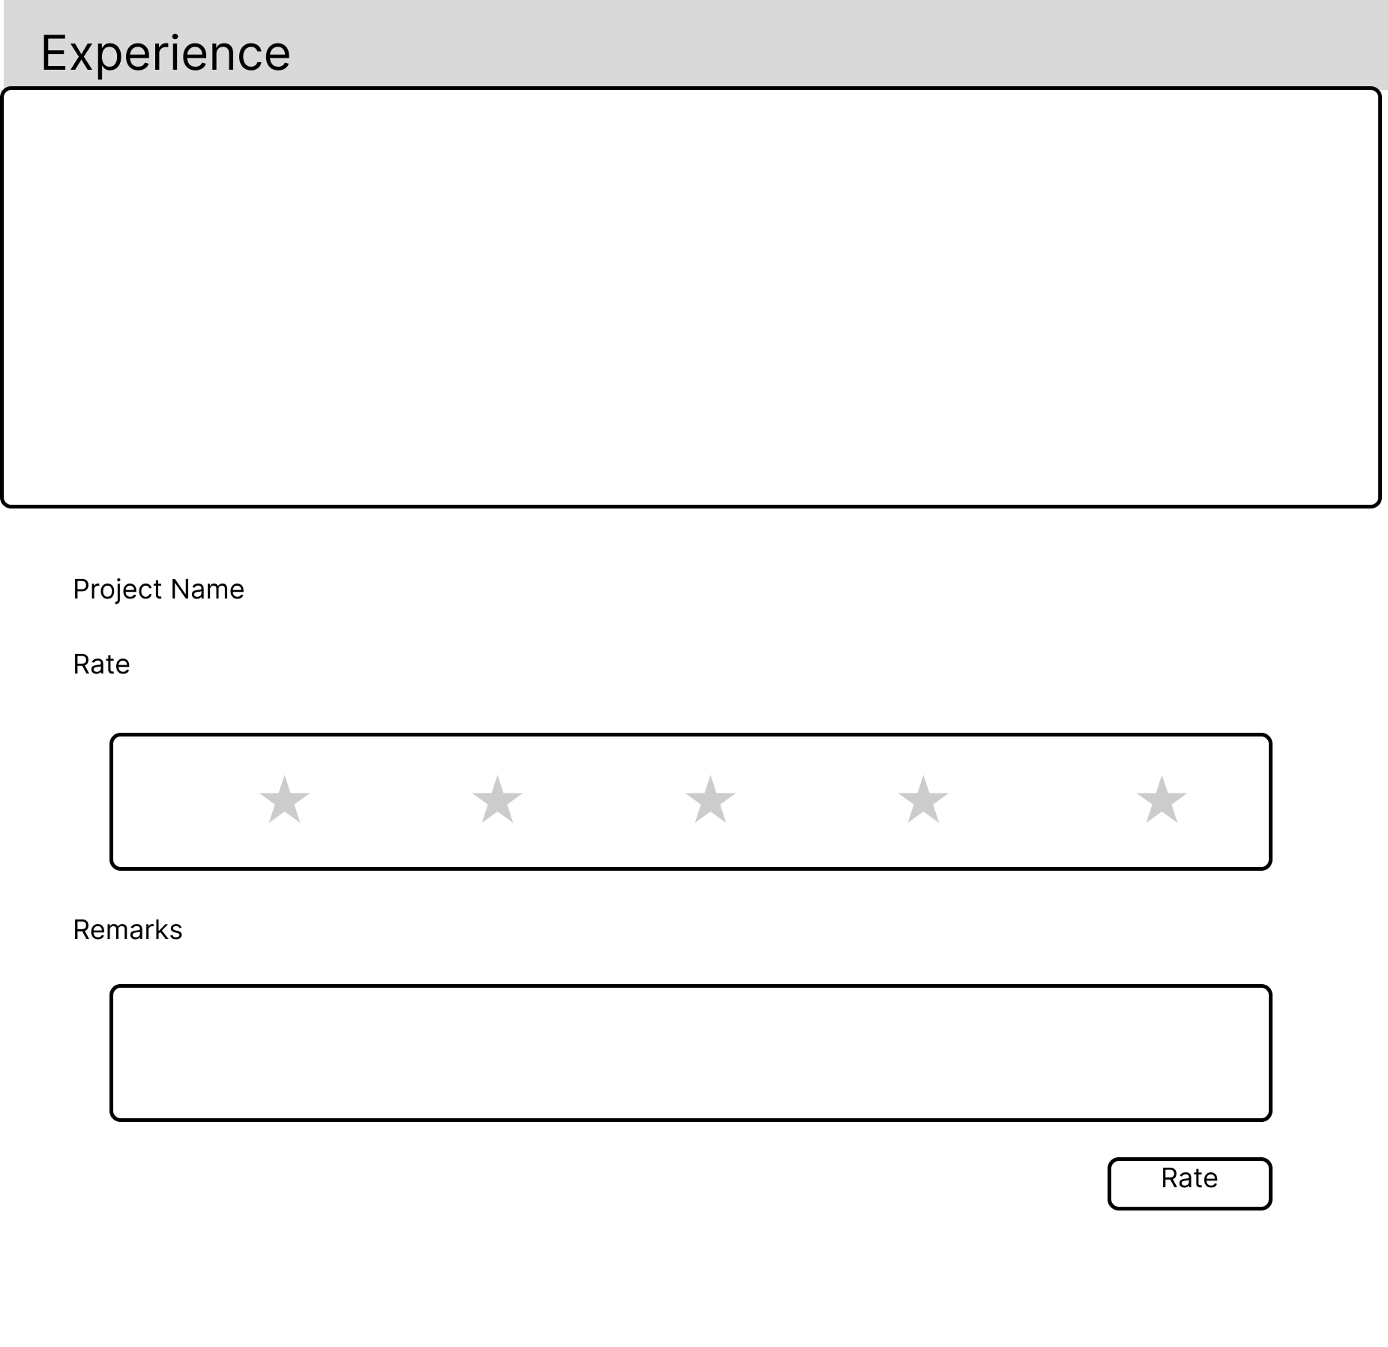

Professional User Applies for the projects

Professional User checks project detail after accepted into the project

Professional User rates project after finishing the project

## Admin Storyboard

### Login and Home Page

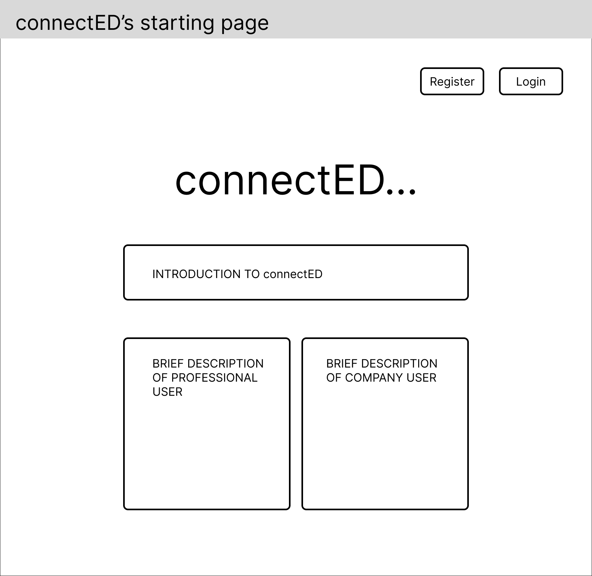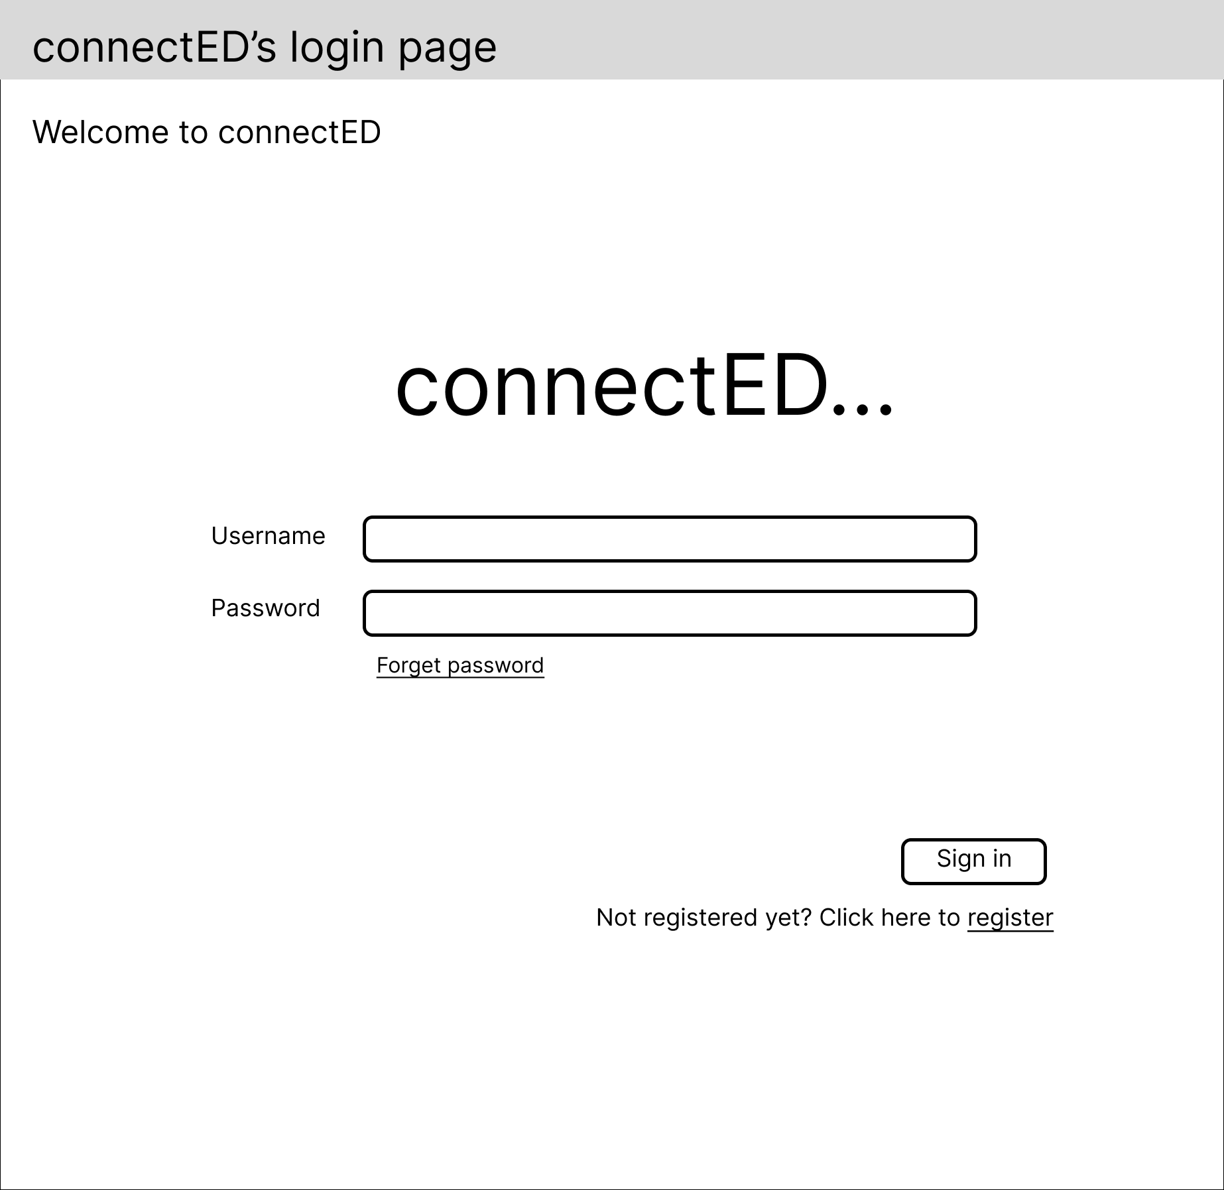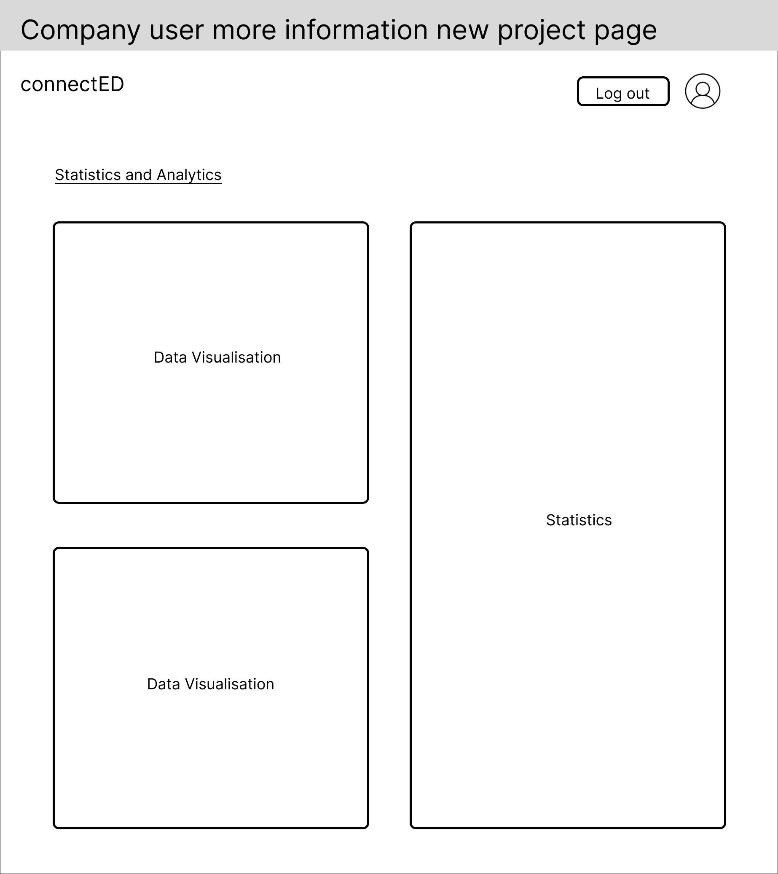

Visitor clicks login

Admin signs in

# System Architecture

The external actors in the proposed system along with technologies/languages that will be used to develop the proposed system can be seen in the system diagram above and will be further explained in the next subsections.

## User Types (External Actors)

### Professional Users

* Skilled Individuals or Professionals that are registered to the platform in order to search and join projects that are posted by companies in the platform.
* Only interacts with the system through the Frontend component in which the Frontend component will fetch or make changes to the data in the backend component based on the user action.

### Company Users

* Individuals from a company who use the platform to post their projects in order to find skilled individuals who are suited and willing to work on their projects.
* Similar to the Professional Users, the company users also only interact with the system through the Frontend component where data will be fetched or changed in the backend component through the frontend component based on the user action.

### Platform Admin

* The platform administrator who is responsible for managing and overseeing the platform.
* Similar to the other two types of users, the platform administrator will interact with the system through the frontend component only.
* Unlike the other two users, the administrator will have a higher editing/manipulating power on the data in the backend system.

## System Architecture Layers

### Interface Layer

The interface layer or the frontend component is the front-facing part of our platform where the user can view and interact with the platform directly. The interface layer will be presented in the form of a website that will consist of multiple pages. The development of the website will be done using Frontend development languages such as HTML, JavaScript, and CSS along with the use of external libraries like React. The React library provides developers with inbuilt functionalities that allows developers to high quality user interfaces more efficiently.

### Business Layer

The business layer is the layer that is responsible for handling all the business logic or functionalities that are needed by the platform such as the signup, edit profile functionality, and much more. Additionally, the business layer also functions as an intermediary between the frontend layer and the database layer as it is responsible for fetching data from the database layer for the frontend layer and modifying data on the database layer based on the request of the frontend layer.

The business layer will be APIs that are developed using the Express web framework along with TypeScript as its development language. We decided to use Express as Express provides various HTTP Utility methods and middleware out of the box, thus allowing us to develop the APIs more efficiently. Additionally, we also decided to use Typescript as it has more features and type safety compared to JavaScript, thus allowing our code to be less prone to errors.

### Database Layer

This layer is responsible for storing all the data for the proposed platform. For this project, we will be using the MongoDB NoSQL database. The MongoDB database will be responsible for creating, updating, and fetching data for the business layer based on the queries or commands provided by the business layer. Besides storing text-based data, the database will also store file-based data such as pdfs or images.

# References

Lau, Y. (2021, June 2). How Organizations Can Become Project-Based In The Future Of Work. Retrieved September 28, 2023, from <https://www.forbes.com/sites/forbeshumanresourcescouncil/2021/06/02/how-organizations-can-become-project-based-in-the-future-of-work/?sh=6fa63b6929e4>

Bragin, N. (2018, September 28). *Top 10 issues with freelancers. Key tips for employers*. Soshace. Retrieved September 29, 2023, from https://soshace.com/top-10-issues-when-hiring-freelancers/

Upwork | The World's Work Marketplace. Retrieved September 27, 2023, from https://www.upwork.com

Hire Freelancers & Find Freelance Jobs Online. Retrieved September 27, 2023, from https://www.freelancer.com/

*Express*. Express - Node.js web application framework. Retrieved September 26, 2023, from https://expressjs.com/

*MongoDB*. MongoDB: The Developer Data Platform | MongoDB. Retrieved September 26, 2023, from https://www.mongodb.com/

*React*. React. Retrieved September 26, 2023, from https://react.dev/

*Typescript*. TypeScript: JavaScript With Syntax For Types. Retrieved September 26, 2023, from https://www.typescriptlang.org/